Business Process, Quality Attributes, User Experience and User Interface (UX/UI) and Data Architecture

Team Orgmatics

# Table of contents

**Table of contents** **1**

**1 Introduction** **2**

**2 Detailed Business Processes and Sub Processes** **3**

2.1 Detail business processes 3

2.2 Map the sub processes to User Stories 15

**3 Identify Quality Attributes** **24**

3.1 Map user stories to quality attributes 30

3.2 Group User Stories based on Quality Attributes 47

**4 UI / UX** **50**

4.1 Create wireframes for important user interactions 50

4.2 UI/UX Architecture 57

**5 Data Architecture** **58**

5.1 Identify Data Entities for each User Story 58

5.2 Build data architecture 59

**6 System level Architectural choices** **60**

**7 Applicable Standards** **63**

7.1 UI/UX 63

7.2 Data regulations / data related 63

7.3 Accessibility 63

# 1 Introduction

It is important to help support individuals in becoming interested in lifelong learning, as well as to encourage those educational efforts in a sustained manner. There are a myriad of potential sources of knowledge and education available, and providing a framework in which to situate those sources towards achieving selected learning objectives is a way of fostering individual interest in learning. By creating a flexible format of setting timetables, learning objectives, and offering curated context to pursue the desired goals, this application will both create a platform for a learner to go to for tracking their learning goals as well as providing a supportive environment and community to sustain and help motivate those sustained efforts.

Current sources of learning are utilized in a “silo” kind of format, wherein a learner can be pulled into deeper levels of learning offered by a platform while losing track of their original learning intentions. With the myriad of learning resources available to users, it is easy for a user to lose sight of their learning objectives, become frustrated, and give up - in essence, losing sight of the forest by way of all the numerous trees. By creating a visual means that allows a learner to see the progress that they are making, utilizing strategic tools and strategies that will optimize the usability of the application, and by creating other supportive approaches (e.g. gamification, social network), this application will help to keep the learning user engaged, focused, and on track. In addition, the platform will help to suggest learning options that will enhance the learning user’s experience, “bubbling up” possible learning courses or materials from the myriad of options through crowdsourcing of knowledge and predictive modeling.

Finally, making this platform as user-friendly and accessible as possible will help core business requirements of scalability while attaining project goals of creating supports for as wide-ranging a user base as possible. By stressing a user-experience portal which embraces dynamic cloud-based microservices, dynamic UI experiences, and other innovative approaches, this application will have built-in flexibility around changing user needs in the future, a sensitivity towards welcoming persons with disabilities, and an invitation to draw the global audience together into a learning community.

# 2 Detailed Business Processes and Sub Processes

## 2.1 Detail business processes

|  |  |
| --- | --- |
| **Key Business processes** | **Sub Processes** |
| 1. Send personalized notifications to learners | * 1. Registering Learner submits email address and optional phone number as required step in registration      1. Email is authenticated as part of the registration process   2. Reminder email and/or phone text is sent if next objective deadline is approaching   3. Reminder email and/or phone text is sent if deadline was missed   4. Reminder email and/or phone text is sent if Learner has not logged in for specified period of time   5. Congratulatory email/phone text is sent when a Learner streak has been achieved   6. Learner is able to customize parameters for reminders or turn off feature   7. Suggestion email or phone app notification is instigated regarding trending LO or curriculum resources |
| 1. Learners create Learning Objective | * 1. Logged-in Learner launches learner Dashboard If there is no active Learning Objective yet with a helper suggestion will offer help to set one up via a pop-up icon/message   2. The learner Dashboard offers a create Learning Objective selection   3. The learner can create a custom Learning Objective or choose to browse the Learning Marketplace to select a pre-completed package      1. The system will recommend Learning Objectives based on area of interest as inputted by learner   4. If the Learner selects the option to create their own Learning Objective, an interactive form will appear offering a variety of inputs:      1. title, themes (goals), duration, sources      2. Tags that are applicable to content and Learning Objective      3. Description   5. Upon submission of Learning Objective, the system will attach a trophy/award for completion |
| 1. Learners archive incomplete Learning Objective | * 1. Logged-in Learner navigates to learner Dashboard   2. Learner can open Learning Objective card and select Archive option   3. Learning Objective status will be populated with ‘Archive’ Status and tag   4. Learner dashboard will offer drop-down display of archived learning objectives   5. Learner can open up an archived Learning Objective to modify status |
| 1. Learners publish complete original Learning Objective | * 1. Logged-in Learner can make progress on a Learning Objective   2. Upon completion of the particular Learning Objective requirements and objectives, the Learner can choose to publish the module   3. Additional input fields will populated the Learning Objective card within the learner Dashboard   4. Learner will be required to add tags, suggested methods for applying the knowledge learned from Learning Objective   5. Upon completion of input fields and submit button, the Learning Objective will populate learning Marketplace   6. Earned trophy/reward will be credited to the Learner’s Trophy Case |
| 1. Learners browse learning marketplace | * 1. Learner can browse learner-submitted Learning Objectives and Curriculum to find content that will support them towards their learning goals   2. The Learning Marketplace will offer a variety of viewing perspectives of published content based on content structure (Curriculum, Learning Objective)   3. Filtered by learning subject area, time duration of learning, types of sources, ratings as given by other learners, author, year of publication   4. Suggestions for discussion threads will be shown dynamically using text matching   5. Trending LOs and Curriculum will be displayed |
| 1. Learners edit original and unpublished Learning Objective | * 1. Logged-in Learner can navigate to learner Dashboard   2. Learner can open up Learning Objective card   3. Learner can edit the input fields associated with the Learning Objective, including updating description, sources, suggestions for application |
| 1. Learners rate and comment on published Learning Objective they have completed | * 1. Logged-in Learner can work on a Learning Objective that they have selected from the learning Marketplace   2. When they successfully complete the Learning Objective, then they will be offered an opportunity to rate the module, offer comments, and add additional ideas around ways to apply the knowledge   3. The comments, ratings, application knowledge data fields will all be used to enrich the learner Marketplace for helping other prospective learners by drop-down or links available to Learning Objectives   4. If the learner does rate, comment, and add application suggestions, then they will be given a reward for their profile |
| 1. Register new and verify learners | * 1. Unregistered leaner navigates to the website where a description of the platform is offered and a link to register and login is provided   2. The learner clicks the link and directed to a sign-up form that requires either an email address or Federated registration using 3rd party application   3. If the learner elects the email registration option, then the system will send a confirmation email for verification   4. Federation identity process will allow other-party applications to provide the user verification steps   5. Newly registered learner will be guided to first login experience display      1. Newly registered learner will be shown all the account creating criteria   6. Multi-factor authentication will be integrated into the registration process for increased security   7. Registering learners will be asked to accept the Terms and Conditions, establishing an agreement to align to community standards of behavior |
| 1. Learners login | * 1. Learners can navigate to the website portal for log-in access   2. Learner can enter their phone number, username, or email address along with password   3. If the inputted data is incorrect, an error message will be displayed, the input fields will be reset, the number of incorrect login attempts counter will be increased by one.   4. If the login account suprasses the admin-decided limit of attempts, then login access will be suspended for a certain period of time   5. Verification tools, such as Captcha or security questions, can be required on a scheduled basis   6. If the user cannot remember his/her email or password, then reset option will be offered ( new unregistered learner registration process ) |
| 1. Learners go through the first login experience | * 1. Having verified their email via verification email, the learner becomes authenticated learner and can login using their credentials   2. The first time that the learner logs in, s/he will be guided through an onboarding process to understand the system and to create their first learning objective      1. The first learning objective will be to follow the guided tutorial on how the system works      2. The first learning objective will be be considered successfully completed if they create the onboarding Learning Objective and publish it   3. Following successful completion of this onboarding process, the learner will have been shown the main features of learning Marketplace, the Dashboard, trophies, 3rd party integration, and how to edit/publish a Learning Objective. |
| 1. Learners manage their accounts | * 1. Each learner will have a system account populated with their optional profile picture or gravatar, required email address, optional phone number, optional areas of interest, enrolled clubs/leagues, privacy controls, and notification preferences   2. Logged-in learned can navigate to their learning Dashboard or via drop down navigation menu to visit their learner profile   3. Once at the learner profile, the learner can edit their information, except for the email address, |
| 1. Display active Learning Objective on learner dashboard | * 1. Logged-in Learner can access their learner Dashboard   2. The Dashboard will offer a variety of data viewing and perspectives:      1. Learning Objective card      2. Curriculum view      3. Trophy/reward to be rewarded         1. Curriculum building blocks (Learning Objective) displayed in sequence         2. Learning Objectives can be selected for greater detail and/or editing         3. Learning Objectives can be dragged/dropped in a flexible way to reflect dynamic approach to learning |
| 1. Display archived Learning Objective on learner dashboard | * 1. Logged in Learner launches the app   2. Learner navigates to their dashboard   3. The “archived” Learning Objective category is displayed on the dashboard      1. If no archived LOs exist, the category is empty |
| 1. Display active curriculum on learner dashboard | * 1. Logged in Learner launches the app   2. Learner navigates to their dashboard   3. The “active” Curriculums category is displayed on the dashboard      1. If no active Curriculums exist, the category is empty      2. Curriculum unit can be selected for greater detail and/or editing |
| 1. Display archived curriculums on learner dashboard | * 1. Logged in Learner launches the app   2. Learner navigates to their dashboard      1. The “archived” Curriculum category is displayed on the dashboard         1. If no archived Curriculums exist, the category is empty |
| 1. Learners filter content on their dashboard | * 1. Logged in Learner launches the app   2. Learned navigates to their dashboard   3. On the dashboard, a search bar is available for learners to search LOs and curriculums based on :      1. title, themes (goals), duration, sources, status (active/archived)      2. When searching, active and archived LOs and curriculums will be considered together |
| 1. Learners rate and comment on published curriculum they have completed | * 1. Learners complete a non original curriculum (built on community recommendations)   2. The rating and commenting features will become available.   3. Learners are required to rate and comment in order to obtain badges.   4. They can perform these actions in two ways :      1. From their dashboard      2. The learning marketplace |
| 1. Learners import trophies/certifications from 3rd-party learning providers | * 1. Logged in Learners navigate to their profile   2. They use “add an external learning certificate” feature   3. They’ll enter the name of the certificate, the source, and the link provided by the 3rd party provider   4. The system will verify the information provided      1. If it’s validated, the certificate will be publicly displayed on the Learner’s profile      2. If not, an error message will be shown and guidance provided to fix the issue |
| 1. Use rewards to incentivize learning | * 1. Learners will earn badges for specific actions      1. Such as ‘learning streaks’ : logging in to the app for consecutive number of days      2. Create X number of LOs/Curriculums..Etc   2. Admins have the possibility to create different awards based on specific objectives   3. When earning rewards and/or points, Learners’ levels increases to show progress |
| 1. Use help features to guide Learners | * 1. Tooltips containing further explanations will be displayed for key features      1. Creating LOs/Curriculums, Social networks, leagues...etc      2. Admins can create further tooltips   2. A help section with the most frequently asked questions will be available      1. The section includes a predictive search bar      2. The help section will be updated over time with more topics   3. Provide a chatbot for 24/7 learner assistance      1. Provide a human assistant choice if the problem is not solved      2. Save conversation data in database   4. Provide helper when intelligent device is connected |
| 1. Enable learners with disabilities to use the application | * 1. At registration, Learners can specify their disabilities      1. If no disabilities are specified, the default version is displayed      2. Otherwise, one or more of the following features will be enabled :         1. Color-blind mode         2. Voice control         3. Narrator mode         4. Visually-diabled friendly font         5. VR, AR content format      3. Constraints on these features would have to be considered based on Learner’s devices (outdated OS/Devices...etc)         1. Platform will be offered in a variety of formats usable across varying devices, operating systems |
| 1. Learners choose a light version of the application | * 1. Learners can choose a version of the app with limited features to ease them into it      1. This can be specified at registration |
| 1. Learners create a curriculum | * 1. After choose “create a new curriculum”, they’re able to choose between 3 modes :      1. Create original curriculum (from scratch)      2. Use community recommended curriculum      3. Use the template based on “Curriculum of the week” published by Admins   2. Depending on choice, Learners are directed to different screens   3. For an original curriculum :      1. Learners have to build every Learning Objective individually   4. For a community recommended curriculum :      1. Learners are invited to type in a name to start the search      2. They can also specify goals (tags) if they don’t have a specific name in mind      3. Additional filters : duration, ratings      4. The result (if valid input) will be in the form of a list of curriculums the Learners can choose from.      5. These curriculums cannot be modified   5. Using “Curriculum of the Week” :      1. When choosing this option, the template will be “copied” to the Learner’s dashboard      2. ‘Curriculums of the Weeks’ are chosen with the help of community experts, they cannot be modified   6. The resulting curriculum will be displayed under ‘Active Curriculums’ on the dashboard |
|
| 1. Learners publish original and completed curriculums | * 1. After completing an original curriculum :      1. When Learners click on the curriculum card on the dashboard, they have the option to “publish” the curriculum to the community      2. Published curriculums can then be used by other Learners, and searched in the Marketplace |
| 1. Learners edit a curriculum they created | * 1. Before completing an original curriculum :      1. When Learners click on the curriculum card on the dashboard, they have the option to edit it      2. They can edit and/or remove individual Learning Objectives, add more LOs to the curriculum, change the name, tags |
| 1. Admins create weekly curriculum templates for learners | * 1. Admins collect opinions from community experts and create templates based on that   2. Admins choose the curriculum template of the week      1. Notify learners through message   3. Admins delete or modify the curriculum template of the week |
| 1. Learners create a social network | * 1. Verify if the learner is allowed to perform this action      1. Deny and send error messages if the learner’s account is locked and not allowed for this action   2. If the recipient approves the request, establish the connection      1. Update the learner’s list of connections      2. Prevent the sender from sending future requests to the connected user   3. Else, sender receives a refusal notification   4. Learners can access the list of connections through dashboard |
| 1. Learners leverage social interactions for a better experience | * 1. On community module, display the top trending Learning Objectives as rated by the community      1. If the learner has created or used Learning Objective, the display by default is subject to the learner’s preferences based on historical data      2. Else, the display is by default the top trending Learning Objectives among all categories of Learning Objectives      3. If the learner search for Learning Objectives by keywords, display the top rated Learning Objectives that contain the searching keywords      4. If the learner choose a tag or a set of tags, display the top rated Learning Objectives that attached the tag or set of tags   2. Learners create a real-time chatroom and invite only online participants from the creator’s network      1. If any participant in the chatroom invite new participants, display only those who are online and from the shared network of all existed participants   3. Suggest connections if the learner’s account is connected to external accounts including Google, Facebook, LinkedIn, and Twitter      1. Only available if the user registered via supported external platforms including Google, Facebook, LinkedIn, and Twitter   4. Learners can start a video broadcast with only selected online users from the existing connections      1. Display the status of the broadcaster as ‘broadcasting’ which other connected users can see through connection list   5. Learners join a live video broadcast      1. Check if the learner is among the connected contacts of the broadcaster      2. If in connections, allow the learner join the broadcast      3. Else, denied the request, notify with error messages   6. Learners can use system integrated language translation features for multi-cultural dialogue   7. Learners can recognize other learners for efforts made to help the community by clicking on the icon next to discussion board; a certain number of these will result in a reward for receiving learner |
| 1. Admins establish leagues to incentivize learning | * 1. Admins set different attributes including theme, time, competing rules, rewards, specific participant requirements, and other necessary descriptions   2. If the leagues is created successfully, updates on the community page   3. Admins can add or remove any learner from a league |
| 1. Learners join leagues | * 1. If the league has participant requirements, check if the learner qualifies   2. If qualified, update the learner’s profile information   3. Update the league database   4. Else, deny and send ‘unqualified’ messages |
| 1. Learners compete in leagues | * 1. If the learner complete all requirements for the league, assign the rewards that are previously specified upon the creation of the league   2. Update the learner’s account information and display the reward in the learner’s profile |
| 1. Learners create clubs to foster collaboration between learners | * 1. Creators specify different attributes including club name, requirements that participant should meet to join it (optional), and other descriptions   2. Update the club database   3. Invite learners      1. Send invite the message      2. If accepted by the recipient, add the recipient to the club   4. If the creator excludes a member, update the member’s account information |
| 1. Learners join clubs | * 1. If the club has requirements, check if the learner qualifies   2. If not, deny and send ‘unqualified’ messages   3. If qualified, send the request to the club   4. If approved, update the club database and learner’s profile information |
| 1. Learners discuss in clubs | * 1. Club members can send or mute messages in/from the club dialog   2. After messages are sent by club members, notify all club members, except for those who mute it   3. If the message @certain members, notify them regardless of their mutation. |
| 1. Admins manage user activities | * 1. Modify the user’s account information based on platform events or requests from users      1. Set learning objectives as "archived"      2. Adding or moving user rewards components      3. View a user’s network list      4. If based on the request, verify that the request is acceptable      5. If based on the request, only modify information addressed by the request      6. Notify all changes to user   2. Track user activity data      1. See user statistics      2. Can export historical data file      3. Set up follow-up notification if necessary   3. View apps statistics report      1. By default display 7 to 14 days worth of data      2. Can export historical data file      3. Report content is based on the metrics created by platform   4. View chatbot conversation report   5. Handle activities of violations      1. Verify that certain user behaviours cause violations      2. Penalize the respective account, options include locking or suspending the account.      3. A message will be sent to the email address linked with the learner’s account with instructions on how to unlock it |
| 1. Admins manage and maintain the application (technical) | * 1. Handle the potential broken-down   2. Application helper settings      1. Upgrade chatbot      2. Modify the helper section      3. Specify a notification when a new different devices(desktop, app, AR, other accessible devices) is connected to an account.      4. Specify a helper to guide a user on connections with acceptable intelligent devices such as Alexa, Google Home, etc.   3. 3rd-party integration control settings   4. Security control settings      1. Control application-wide settings such as permission for certain access to enhance levels of security   5. Application updates settings |
| 1. Learners suggest applications of learning after they comment or rate a published curriculum or Learning Objective | * 1. If the learner successfully comment or rate a published curriculum/Learning Objective, they are given the option to input advice on application of learning   2. After the learner submit, application ideas are saved with Curriculum and Learning Objective tags   3. update the database |
| 1. Learners get suggestions on applications after they complete a curriculum or Learning Objective | * 1. If learners successfully created a curriculum or Learning Objective, display suggestions on application of knowledge that are related to the curriculum/Learning Objective tags |

## 2.2 Map the sub processes to User Stories

|  |  |  |
| --- | --- | --- |
| **Epics** | **User Stories** | **Sub Processes** |
| 1 Learning Objective | User Story 01: As a learner, I want to create objective, sources, duration | 2.1, 2.2, 2.3, 2.4 |
| User Story 02: As a learner, I want to edit, modify attributes | 6.1, 6.2, 6.3 |
|  | User Story 03: As a learner, I want the ability to archive Learning Objective | 3.2, 3.3 |
|  | User Story 04: As a learner, I want to be able to publish a learning objective | 4.1 ,4.2 ,4.3, 4.4, 4.5, 4.6 |
|  | User Story 05: As a learner, I want to create a Learning Objective based on system recommendation | 2.3, 2.3.1,, 5.1, 5.2 |
|  | User Story 06: As a learner, I want to be able to rate and comment on Learning Objectives I have used | 7.1, 7.2, 7.3, 7.4 |
| 2 Dashboard | User Story 01: As a learner, I want to be able to access content such as my learning objectives as a card displaying main information | 12.1, 12.2, 12.2.1, 12.2.2, 12.2.3, 12.2.3.1, 12.2.3.2, 12.2.3.3 |
|  | User Story 02: As a learner, I want to be able to access curriculum as a card displaying higher-level of curriculum building blocks | 14.1, 14.2, 12.2.1, 14.3, 14.3.1, 14.3.2 |
|  | User Story 03: As a learner, I want to be able to access a single curriculum module to examine the details and information around that curriculum learning path | 14.3.2, 12.2.3.1, 14.3.2 |
|  | User Story 04: As a learner, I want to be able to switch between different views based on filters | 16.1, 16.2, 16.3, 16.3.1, 16.3.2 |
|  | User Story 06 : As a Learner, I want to comment and rate Curriculums I have completed | 17.1, 17.2, 17.3, 17.4, 17.4.1, 17.4.2 |
|  | User Story 07 : As a Learner, I want to publish my original and completed Learning Objectives/Curriculums to the community | 24.1, 24.1.1, 24.1.2 |
|  | User Story 08 : As a Learner, I want to be able to click on an original curriculum card to have the possibility to edit it | 25.1, 25,1,1, 25,1,2, 6.1, 6.2, 6.3 |
| 3 Curriculum | User Story 01: As a user, I can create new curriculum using a given template using community-approved content | 23.4 |
|  | User Story 02: As a user, I can create a new curriculum module/node that can be used by others in the community. For example, reading an article or watching a podcast, and then writing a paper or sharing what has been learned can then be added to Knowledge Pool for usage by other learners. | 24.1 |
|  | User Story 03: As an admin, I want to be able to have community experts build the recommended path for a learning objective. | 23.1.2, 26.1 |
|  | User Story 04 : As a Learner, I want to create a curriculum based on the suggested “curriculum of the week” template | 23.5.2 |
| 4 3rd Party integration | User Story 01: As a user, I can share a badge or award earned on another platform (Coursera, Udemy, Lynda.com, AWS certification) on my trophy case within the application | 18.1, 18.2, 18.3, 18.4 |
| 5 Portability | User Story 01: As a user I want to be able to access this application on mobile phone, laptops of varying screen sizes and operating systems | 21.1.3.1 |
| 6 Accessibility Expansion | User Story 01: As a person with particular special needs, I want to be able to control the application and interact with it using voice control | 21.1.2.2 |
|  | User Story 02: As a person with color blind vision, I want to have access to color blind mode for increased visual acuity | 21.1.2.1 |
|  | User Story 03: As a person with visual disabilities, I want to be able to select a different system font | 21.1.2.4 |
|  | User Story 04: As a user, I want to be able to communicate with individuals from other regions of the world by using texting tools that bridge the communication gap | 28.6 |
|  | User Story 05: As an elderly person with knowledge and skills, I want to be able to share my knowledge in very-accessible ways that minimize technological complexity | 22.1 |
|  | User Story 06: As a learner with physical and/or visual disabilities, I want to be able to interact with learning content using VR or AR | 21.1.2.5 |
| 7. Application of Learning | User Story 01: As a user, I want to be able to put my learned knowledge / experience in new and innovative ways, tutoring and connections | 29, 37, 38 |
| 8. Engagement | User Story 01: As a learner, I want to be notified if my deadline set for next objective is approaching, or if I missed a deadline that was declared on curriculum, or if I haven't log in for /two days/, in case I forget my learning things during some busy time. | 1.2,1.3,1.4 |
|  | User Story 02: As a learner, I want to catch up with trending learning resources/learning objectives(e.g. ML is popular right now) by receiving emails(desktop) or receiving notification (phone app), so that I know what type of knowledge and skills is coming in fashion and I could probably consider that as my next learning target. | 1.7 |
|  | User Story 03: As an admin, I want to track users' activity data so that I know when to cold/warm follow-up or retain potentially draining users. | 35.2 |
|  | User Story 04: As an admin, I want to have a real-time/periodically statistics in terms of what are being discussed on the platform so that I use that to advertise both old and new customers. | 35.3 |
| 9. Registration and Login | User Story 01: As an unregistered learner, I want to see a sign-up link on the main page, receive a confirmation email to my registered email address, and guided to new-user landing page | 1.1, 8.1, 8.2, 8.3 |
|  | User Story 02: As a registered learner, I want to know all account creating criteria through the registering process. | 8.1 |
|  | User Story 03: As an admin, I want to require one click through confirmation email from newly registered learners to ensure registration information is valid | 8.3 |
|  | User Story 04: As an admin, I want to define input data fields on a log-in/sign-up screen for a registering learner, including username, password, password confirmation, security question, security answer | 8.2 |
|  | User Story 05: As an admin, I ask learners to accept the Terms and Conditions before moving on to meet legacy requirements | 8.7 |
|  | User Story 06: As an unregistered learner, I want to see the option to sign up using a third-party federated log-in process | 8.2 |
| 10. Helper | User Story 01: As a new learner who just created an account, I want to be shown a quick and simple guide on the main features of this platform in a logical order (e.g. setting objective first, then building curriculum, then building connections) | 10.1, 10.2, 10.3 |
|  | User Story 02: As a learner, I want to follow a guide on how to build my own curriculum | 10.2.1, 10.2.2 |
|  | User Story 03: As a learner, I want to see hint on all sections of a dashboard/menu/tab | 20.1, 20.2, 20.3 |
|  | User Story 04: As an admin, I want to offer a helper when a new different devices(desktop, app, AR, other accessible devices) is connected to an account. | 20.1 |
|  | User Story 05 : As a Learner, I want to have access to a help section with the most frequently asked questions displayed and the ability to search help topics | 20.2, 36.2.1 |
|  | User Story 06: As an admin, I give users helper messages to connect their acceptable intelligent devices such as Alexa, Google Home, etc. | 20.4, 36.2.2 |
|  | User Story 07 : As a Learner, I want to have access to a chatbot for 24/7 assistance on the app | 20.3 |
| 11. Social Network / Sharing | User story 01: As a Learner, I want to create connections with others | 27.1, 27.2, 27.3 |
|  | User Story 02: As a Learner, I want to see my network (list of connections) | 27.4 |
|  | User Story 03 : As a Learner, I want to create a chatroom and invite my connections | 28 |
|  | User Story 04 : As a Learner, I want to see the top trending LOs in the community (based on filters) | 5.5 |
|  | User Story 05 : As a Learner, I can connect to Learners I know from external platforms including Google, Facebook, LinkedIn, and Twitter. | 28.3 |
|  | User Story 06 : As a Learner, I want to broadcast myself to my network | 28.5 |
|  | User Story 07 : As a learner, I want to recognize a Learner for service provided | 28.7 |
| 12. Leagues / Club | User Story 01: As a Learner, I want to be able to register in leagues and compete with other Learners | 30, 33 |
|  | User Story 02 : As a Learner, I want to be able to create collaboration clubs with other Learners | 32 |
|  | User Story 03 : As a Learner, I want to be able to compete with other learners in time-based challenges with specific rewards at completion | 31 |
|  | User Story 04 : As a Learner, I want to have a public discussion space under the League/Club to exchange information and opinions with other Learners | 34 |
|  | User Story 05 : As a Learner, I want to be able to add/exclude learners from my club | 32 |
| 13. Gamification | User Story 01: As a Learner, I want to get rewards (badges, points...etc) for completing specific objectives (learning objective, curriculums, challenges, leagues...etc) | 19.1, 19.2 |
|  | User Story 02 : As a Learner, I want to be able to have progression levels that continually improve as I complete more objectives | 19.3 |
|  | User Story 03 : As a Learner, I want to see the reward displayed with each objective | 2.5, 12.2.3 |
|  | User Story 04 : As a Learner, I want a specific badge/reward after getting x number of recognitions | 28.7 |
| 14. Learner Profile | User Story 01 : As a Learner, I want to see my personal information profile picture | 11.1, 11.2 |
|  | User Story 02 : As a Learner, I want to see my points, levels, badges/trophy gallery...etc | 11.1, 11.2 |
|  | User Story 03 : As a Learner, I want to change my personal information and profile picture | 11.3 |
|  | User Story 04 : As a Learner, I want to hide some of my information from people outside of my network | 11.1 |
| 15. Platform Administration | User Story 01 : As an admin, I want to track users' activity data so that I know when I should follow up to retain potentially draining users | 35.2 |
|  | User Story 02 : As an admin, I want to receive content of conversations in the chatbot, and switch it to human assistants whenever possible to offer sufficient help | 35.4 |
|  | User Story 03: As an admin, I want to have a real-time/periodically statistics in terms of trending learning topics/resources on the platform | 35.3 |
|  | User Story 04: As an admin, I want to create a helper manual that all users have access to | 20.3, 36.2 |
|  | User Story 05: As an admin, I want to set learning objectives as "archived" for a specific user | 35.1.1 |
|  | User Story 06: As an admin, I want to see the list of learning objectives per user with all the details and ratings | 35.2 |
|  | User Story 07: As an admin, I want to see a learner's full profile, creation date...Etc | 35.2 |
|  | User Story 08 : As an admin, I want to have the different administration features available (creating/deleting LOs, suspending accounts, adding/removing points...Etc) | 28.1, 35.1.2, 35.5.2 |
|  | User Story 09 : As an admin, I want to have access to platform Analytics to track the platform's health, learners activity...Etc | 35.3 |
|  | User Story 10 : As an admin, I want to enable multi-factor authentication for Learners | 8.6 |
|  | User Story 11 : As an admin, I want to create time-based challenges with specific rules and requirements (duration, rewards...) | 29.1 |
|  | User Story 12 : As an admin, I want to create the leagues and rules and requirements to be able to join them (topic, duration, learning outcome...Etc) | 29.1 |
|  | User Story 13 : As an admin, I want to change the attributes and metadata of learning objectives by user | 35.1 |
|  | User Story 14 : As an admin, I want to change a Learner's personal information | 35.1 |
|  | User Story 15 : As an admin, I want to be able to reset a Learner's level | 35.1 |
|  | User Story 16 : As an admin, I want to be able to modify or delete a template | 26.3 |
|  | User Story 17 : As an admin, I want to be able to build templates based on specific rules (specific LOs names, specific community ratings...etc) | 26.1 |
|  | User Story 18 : As an admin, I want to be able to add/subtract points/badges...etc to and from specific learners | 19.2, 35.1.2 |
|  | User Story 19 : As an admin, I want to add/remove any learner from any League | 29.3 |
|  | User Story 20 : As an admin, I want to see each user's network | 35.1.3 |
| 16. Learner Marketplace | User Story 01 : As a Learner, I want to see the different Learning Objectives created by the community, based on areas of learning, duration, sources, ratings...etc | 5.1 |
|  | User Story 02 : As a Learner, I want to comment and rate Curriculums and/or Learning Objectives I completed | 17.1, 17.2, 17.3, 17.4, 7.1, 7.2, 7.3, 7.4 |

# 3 Identify Quality Attributes

In the application, ensuring that the user stories, business processes, and sub processes meet the applicable levels of quality that are expected in terms of performance, security, and a variety of other attribute metrics is essential to ensure a robust and compliant experience. Following are a variety of quality attributes that will be used as standards from which to justify the architecture, deployment, usability, and operational aspects related to the decisions made in architecting this solution.

**Availability** (Service Level Agreement)

The availability of the application is the time period in which the service will be available for use by learners and administrators. By replicating EC2 server instances and databases within different Availability Zones, the application will celebrate redundancy with administrator-given automation for a crashed instance to automatically fall back to another instance. This will minimize any non-availability as experienced by the user. In addition, by automating snapshots of the server and database configurations and point-in-time data stores, any disruption in the service can be handled smoothly by spinning up additional instances from the snapshot. All data captured within the platform will be saved to Glacier-level AWS storage; for a minimal charge, all of the data will be replicated to yet another degree of safety. This data can be retrieved for free if a few hours delay is approved, otherwise an expedited fee can be paid for faster retrieval. Maintenance scheduling will be done at off-peak hours, such as 3am in whichever Availability Zone the server is located.

**Security**

The security of the application demands robust measures and thoughtful design and preparation, both for compliance with ever-narrowing privacy laws and regulations, but to ensure confidence and loyalty of the user base who otherwise might flee if their data is compromised. Security is related to 1) the question regarding who has access to what data within the application, as well as related permissions to effect change, as well as 2) the secure status of the data itself. Following are additional information related to each of these aspects:

*Application Access and Permissions*

Access to the application will be limited to registered learners and administration staff. Only registered learners will be able to utilize the various tools and features offered by the application, such as creating learning objectives and curriculum, joining a community, and participating in competitions. A learner will be able to edit his/her profile and content, post messages to the community, and otherwise manipulate data related to his/her learning objective, but will be restricted from effecting changes on a systemic level, other person’s content.

The following Roles and Permission Matrix details this security approach in terms of Learners, Administrators.

|  |  |  |
| --- | --- | --- |
| **Account** | admin | learner |
| Update learner profile | x | x |
| Create learner account | x | x |
| Delete learner account | x | x |
| Create learning objective |  | x |
| Edit learning objective | x | x |
| Delete Learning Objective | x | x |
| Archive Learning Objective | x | x |
| Publish Learning Objective | x | x |
| Edit Marketplate content, UI | x |  |
| Comment on Learning Objective | x | x |
| Login | x | x |
| Engage in social network | x | x |
| Compete in leagues |  | x |
| Create club |  | x |
| **System** |  |  |
| Modify Notification parameters | x |  |
| Modify IAM policies | x |  |
| Modify firewall and microservice parameters | x |  |
| Notify learner of non-compliance of community standards | x |  |
| Modify UI component structures (dashboard, landing screen, etc) | x |  |
| Engage companies for real-life rewards/trophies | x |  |
| Create weekly curriculum template | x |  |
| Moderate social network in case of red flag | x |  |
| Establish leagues for competition | x |  |
| Manage user activities | x |  |
| Maintain the application | x |  |

*Data Protection*

There will be different levels of data classification: public, internal, restricted.

Public data is that which can be viewed from the application landing page by any public user, and will be generic in nature and detailing the highlights and benefits of joining the application community as a registered learner.

Internal data is that which will be used for the setup, maintenance, and ongoing operations related to the application. This data will not be viewed or accessible by a learner, but only by administrators. Internal data will have varying levels of levels in terms of access, depending on the accessing administrator. This will be regulated by group policies and by roles - different administrators can have different authorized levels of access. Examples of internal data will be information related to a competition - trophy to be rewarded, time parameters, rules. This information will be persisted in memory storage, able to be queried, modified, and accessed for display to the application. The data itself can only be modified by authorized administrators.

Restricted data is similar to internal data in that it is restricted to certain roles and groups, but in this case it is restricted to individual learners. For example, a learner will create an account, populate the data with personal data such as 3rd party integration, password, username, learning objective, trophies earned, and so forth. This data is personal and related to a particular individual, and that data will be restricted solely to that particular learner. Within the application, the learner can choose to share certain aspects of their information to other learners or to the community, but that will be up to them as part of privacy controls. Due to the private nature of this data, utilizing HTTPS instead of HTTP for increased packet transmission will be pursued. In addition, data packets both at rest and in transition will be encrypted using AWS-side keys.

**Portability**

The application will use a front-end agnostic rendering language such as React Native which can run on top of many underlying platforms, including Android, Apple, Windows, IOS, etc. Whereas other languages would have to be translated from one system to another, this approach would allow for a single-source of coding, minimizing resources, coding efforts and administration. It will be compatible with varying operating systems, hardware environments.

Due to the utilization of cloud platform, such as AWS or Azure, this application will be able to take advantage of microservice architecture. For example, the system could utilize cutting edge technologies as translation services or the suite of video services that are available in a massively scaling manner. By using edge location availability and global availability zone access, the application will be available on a global level to an audience of various nationalities.

**Performance**

The application will use a robust language such as PHP or Node.js on the back-end, with the latter offering asynchronous multithreaded scalability particularly in conjunction with a NoSQL database. By spinning up EC2 servers in the cloud or using Lambda, the instances can be scaled up or down, minimizing expenses and minimizing lag times. 600k concurrent websocket connection can be obtained on AWS using Node.js. Amazon DynamoDB can handle more than 10 trillion requests per day and can support peaks of more than 20M requests per second. Every .5 seconds can result in traffic dropping by 20 percent, so our application will aim for reduced latency.

**Usability**

The application will stress ease of use as part of its mission to increase accessibility and increase user base. Helper functions will be available for all the main business processes to help guide the inexperienced learner to understanding the application features. Dashboard appearances will aim for displaying information in a simplified format that will invite the learner to drill down as needed.

**Testability**

As each component of the application is developed, the codebase will be structured to increase automated testing, deployment to as much an extent as possible. A-B testing will be embraced so that new features and UI modifications can be tested and optimized without affecting the main content.

**Scalability**

Scalability is the capability of a system, network, or process to handle a growing amount of work, or its potential to be enlarged to accommodate that growth

By using cloud resources and infrastructure, the application will be well poised to scale as needed. S3 buckets can hold unstructured data such as objects that can be PUT up to 5 GB per object. Larger objects can use Multipart Upload capability. AWS NoSQL databases can scale out using distributed clusters of hardware, and since they are fully managed, such vertical reaction to demand is possible with a minimum of effort from staff.

**Agility**

Flexibility in supporting new business models, enables service discovery and provides visibility into business process health

The application will have the internal and deployment model which inherently embraces dynamic changes. The learner will be able to add, edit, modify, archive, and publish new learning objectives and curriculum. Published content will be added to the learning community’s marketplace, transcending hardcoded learning resources. The load upon the administrator will be minimilzed due to the automation and configuration benefits afforded by cloud platforms. The global nature of the application, serving learners from different regions of the world, will allow agility for welcoming new subscribers (learners) - as the learner base grows, so will the community conversations and connections, published content, and scaling desirability of joining the application.

**Supportability (aka Serviceability)**

How effectively a software system or component can be kept running after deployment, based on resources that include quality documentation, diagnostic information, and both knowledgeable and available technical staff.

The platform will be built with a focus on automation, scalability, and utilization of technological tools that increasingly allow for a minimization of human intervention. The application will be built using an architectural approach that will emphasize sustainability, ease of use (for both the learner and administrator) and ease of making adjustments. This can be obtained through careful planning of systemic policies and a cloud architecture that is built with security and operational simplicity goals in mind.

**Accessibility**

The application will emphasize tools and options to emphasize the usability of the application for individuals with a wide spectrum of disabilities. Whether those disabilities might challenges in the areas of vision, motor skills, cognitive challenge, or other, this application will set a high goal of making the user interface and experience as welcoming and easy to use as possible. Options will be available to have helpers assist the learner - both “hardwired” tooltips or intelligent chatbot-styled system conversations. Different fonts styles and colors and other controls that will make the visual display easier to read will be described to the beginner learner after he or she has registered. The marketplace will use predictive modeling techniques and/or tags to give appropriate suggestions of areas to consider for the learner as s/he considers their learning objective. Tools such as language translation and the capacity of new technologies such as AR/VR will be offered when that content is created either by the administrator or learner.

**Adaptability**

The application will emphasize a flexibility and dynamic means of responding to changes both in terms of responding to learner’s and user’s needs and interests, as well as to external changes within technology. By adopting an agile approach to changes, understanding that this is an inherent aspect of technology, this platform will be able to remain relevant and more accessible in the future.

## 

## 

## 

## 

## 

## 

## 

## 

## 3.1 Map user stories to quality attributes

|  |  |  |  |
| --- | --- | --- | --- |
| **Epics** | **User Stories** | **Quality attributes mapping** | **Justification for the mapping** |
| 1. Learning Objective | User Story 01: As a learner, I want to create objective, sources, duration | Usability | It should be possible for the Learner to create a goal that they are working towards |
|  | User Story 02: As a learner, I want to edit, modify attributes | Usability, Adaptability | Usability: Learner should be able to make modifications related to changing interests or needs  Adaptability: Ability of the system to adapt to changing conditions to provide dynamic Learner experience |
|  | User Story 03: As a learner, I want the ability to archive Learning Objective | Usability | Learner might not want to continue that learning path |
|  | User Story 04: As a learner, I want to be able to publish a learning objective | Usability | Successful completion of content can then be shared, which can be useful to others in the community |
|  | User Story 05: As a learner, I want to create a Learning Objective based on system recommendations | Usability | The system can help curate learning resources to make the experience more relevant to Learner |
|  | User Story 06: As a learner, I want to be able to rate and comment on Learning Objectives I have used | Usability | Recommendations can help other learners decide useful resources to use |
| 2. Dashboard | User Story 01: As a learner, I want to be able to access content such as my learning objectives as a card displaying main information | Usability,  Performance | Usability : The learner must be able to view all their LOs and curriculums while still be able to navigate the app easily and smoothly.  Scalability : This feature must work equally well with 1 LO/Curriculum as with 100s.  Performance : The display shouldn’t take too long (1-3 seconds)  The platform should support 2000 concurrent learners |
|  | User Story 02: As a learner, I want to be able to access curriculum as a card displaying higher-level of curriculum building blocks | Usability, Scalability | Usability : The learner must be able to clearly see the information displayed on the card  Scalability : It must work for one or hundreds of curriculums |
|  | User Story 03: As a learner, I want to be able to access a single curriculum module to examine the details and information around that curriculum learning path | Usability | Usability : The learner must be able to perform the action simply and without friction |
|  | User Story 04: As a learner, I want to be able to switch between different views based on filters | Usability  Scalability  Performance | Usability : The filters should be clearly visible and intuitive to use  Scalability : The filters should work regardless of the numbers of available LOs or curriculums  Performance: The switch between views must be swift (1 - 2 seconds) |
|  | User Story 05: As a learner, I want to be able to get more details about my progress and curriculum | Usability, Scalability,  Performance | Usability : The dashboard should display the summed up information regarding the Learner’s content  Scalability : The dashboard should qork equally for 1 or 100 components  Performance : the dashboard loading time must be short (1 - 3 seconds) |
|  | User Story 06 : As a Learner, I want to comment and rate Curriculums and/or Learning Objectives I completed | Usability, Performance | Usability : Rating and commenting should be available immediately after the requirement is met  Performance : the rating/comment should be displayed to the Learner rapidly (1-2 seconds) |
|  | User Story 07 : As a Learner, I want to publish my original and completed Learning Objectives/Curriculums to the community | Usability, Performance | Usability : Publishing should be available immediately after the requirement is met  Performance : the action must be completed rapidly (1-2 seconds) |
|  | User Story 08 : As a Learner, I want to be able to click on an original curriculum card to have the possibility to edit it | Usability | Usability : The feature should be available for each original curriculum |
| 3. Curriculum | User Story 01: As a Learner, I can create new curriculum using a given template using community-approved content | Usability, Scalability, Performance | Usability : The creation process must be streamlined and easy to follow  Scalability : The process should work equally for a few community content as for a lot  Performance : The community suggestions should be available quickly (1-2 seconds) |
|  | User Story 02: As a user, I can create a new curriculum module/node that can be used by others in the community. For example, reading an article or watching a podcast, and then writing a paper or sharing what has been learned can then be added to Knowledge Pool for usage by other learners. | Usability | Usability : Creating a curriculum from scratch must be streamlined |
|  | User Story 03: As an admin, I want to be able to have community experts build the recommended path for a learning objective. | Usability, Testability | Usability : This template should be easily built and maintained by the admins  Testability : The template should be tested before being published |
|  | User Story 04 : As a Learner, I want to create a curriculum based on the suggested “curriculum of the week” template | Usability | Usability : The template should be built easily by the learners |
| 4. 3rd Party integration | User Story 01: As a user, I can share a badge or award earned on another platform (Coursera, Udemy, Lynda.com, AWS certification) on my trophy case within the application | Usability, Security, Supportability | Usability : The integration should be smooth and seamless with few steps.  Security : The integration should happen securly, preserving the learner’s personal information  Supportability : The system should support multiple external platforms |
| 5. Portability | User Story 01: As a user I want to be able to access this application on mobile phone, laptops of varying screen sizes and operating systems | Supportability  Portability | Flexibility : The app should work equally on multiple devices  Supportability : The same codebase should be reused for all versions of the platform  Portability: The app will be available ton mobile, laptop, desktop screen formats and different OS |
| 6. Accessibility Expansion | User Story 01: As a person with particular special needs, I want to be able to control the application and interact with it using voice control | Usability, Performance  Accessibility | Usability : The learner should be able to navigate the app using voice smoothly  Performance : The app should as responsive as with standard mode  Accessibility: Alternative way of navigating the app will allow for increased use of app as well as more people able to use it |
|  | User Story 02: As a person with color blind vision, I want to have access to color blind mode for increased visual acuity | Usability  Accessibility | Usability : The app should remain as equally usable as with standard mode  Accessibility: Different features tailored to persons with color blindness will make app more usable |
|  | User Story 03: As a person with visual disabilities, I want to be able to select a different system font | Usability  Accessibility | Usability : The app should remain as equally usable as with standard mode  Accessibility: Different fonts are more easily able to be read |
|  | User Story 04: As a user, I want to be able to communicate with individuals from other regions of the world by using texting tools that bridge the communication gap | Usability, Scalability, Accessibility | Usability: Will foster a greater community of learners to share with  Scalability: Will allow multi-language and region participation  Accessibility: will allow non-English speakers to utilize the platform through translation of content |
|  | User Story 05: As an elderly person with knowledge and skills, I want to be able to share my knowledge in very-accessible ways that minimize technological complexity | Accessibility Usability | Accessibility: make the platform more accessible to more people and more user-friendly  Usability : The platform should facilitate ease of use |
| 7. Application of Learning | User Story 01: As a user, I want to be able to put my learned knowledge / experience in new and innovative ways, tutoring and connections | Usability | Usability: The input should be collected and interpreted properly to support the function of suggesting the application of knowledge |
| 8. Engagement | User Story 01: As a learner, I want to be notified if my deadline set for next objective is approaching, or if I missed a deadline that was declared on curriculum, or if I haven't logged in for two days, or in case I forget my learning things during a busy time. | Usability | Such prompts will help learners feel connected |
|  | User Story 02: As a learner, I want to catch up with trending learning resources/learning objectives(e.g. ML is popular right now) by receiving emails(desktop) or receiving notification (phone app), so that I know what type of knowledge and skills is coming in fashion and I could probably consider that as my next learning target. | Usability | Being made aware of what’s popular will help keep the learner engaged and foster a smoother learning path |
|  | User Story 03: As an admin, I want to track users' activity data so that I know when to cold/warm follow-up or retain potentially draining users. | Usability | Having access to engagement data can help admin know how to make system decisions |
|  | User Story 04: As an admin, I want to have a real-time/periodically statistics in terms of what are being discussed on the platform so that I use that to advertise both old and new customers. | Usability | Admin data related to engagement will help drive decisions affecting learners in the system |
| 9. Registration and Login | User Story 01: As an unregistered learner, I want to see a sign-up link on the main page, receive a confirmation email to my registered email address, and guided to new-user landing page | Usability  Security | Usability: Such a registration process is common for helping to ensure the provided email is valid  Security: email confirmation will help to weed out spam |
|  | User Story 02: As a registered learner, I want to know all account creating criteria through the registering process. | Usability | Giving learners the information needed to become familiar with the platform will help them feel engaged |
|  | User Story 03: As an admin I want to require one click through confirmation email from newly registered learner to ensure register info is valid | Usability  Security | Usability: Confirmation email process is helpful for weeding out spam  Security: ensuring a valid email is part of ensuring authorized use |
|  | User Story 04: As an admin, I want to define input data fields on a log-in/sign-up screen for a registering user with username, password, re-enter password, security question, security answer | Usability  Security | Usability: Capturing essential learner data as well as the login information will be essential for inputting learner into database  Security: having a password and security question will help for validating learner upon login process |
|  | User Story 05 As an admin I ask learners to accept the terms and conditions before moving on to meet legacy requirements | Usability | Creating common rules are important for creating guidelines and standards |
| 10. Helper | User Story 01: As a new learner who just created an account, I want to be shown a quick and simple guide on the main features of this platform in a logical order (e.g. setting objective first, then building curriculum, then building connections) | Usability | A guide like this can help make the platform easier to understand and make it more usable to the learner |
|  | User Story 02: As a learner, I want to follow a guide on how to build my own curriculum | Usability | A guide like this can help make the platform easier to understand and make it more usable to the learner |
|  | User Story 03: As a learner, I want to see hint on all sections of a dashboard/menu/tab | Availability, Usability, Scalability | Availability : This feature must be provided  Usability : The hints should be easy to interpret and use  Scalability : The feature must scale well with the number of curriculums/ LOs |
|  | User Story 04: As an admin, I want to offer a helper when a new different devices(desktop, app, AR, other accessible devices) is connected to an account. | Availability, Testability, Security | Availability : This feature must be provided  Testability : This feature must be tested before made public  Security : Ensure the learner’s accounts and personal information is securely connected |
|  | User Story 05 : As a Learner, I want to have access to a help section with the most frequently asked questions displayed and the ability to search help topics | Availability, Usability, Performance | Availability : The feature must be provided  Usability : The learner should be able to easily navigate to the help section and search for topics  Performance : The section should load rapidly regardless of the number of available topics |
|  | User Story 06: As an admin, I give users helper messages to connect their acceptable intelligent devices such as Alexa, Google Home, etc.  . | Testability, Usability | Testability : The feature should be tested before made public  Usability : Ensure the feature works and the connections to external devices is enabled |
|  | User Story 07 : As a Learner, I want to have access to a chatbot for 24/7 assistance on the app | Availability,  Usability,  Performance | Availability: The chatbot should be available 24/7  Usability: The chatbot is able to perform conversations  Performance: The satisfaction rate(numbers of helpful conversation versus the total number of conversations) should be higher than 80% |
| 11. Social Network / Sharing | User story 01: As a Learner, I want to create connections with others | Usability,  Performance | Usability: creating connections will help the Learner feel more engaged for achieving learning goals  Performance: The app complete the request and update the result no longer than 0.1s after the action performed by users |
|  | User Story 02: As a Learner, I want to see my network (list of connections) | Usability | Usability: The list is shown in an intuitive format |
|  | User Story 03 : As a Learner, I want to create a chatroom and invite my connections | Usability,  Performance | Usability: It should be easy to create a chatroom  Performance: The time for the system to complete invitation requests no longer than 0.1s |
|  | User Story 04 : As a Learner, I want to see the top trending LOs in the community (based on filters) | Usability | Usability: The app should provide correct results based on filters |
|  | User Story 05 : As a Learner, I can connect to Learners I know from external platforms (LinkedIn, Twitter...Etc) | Adaptability | Adaptability: Network connecting module should facilitate integration with 3rd party systems. The application should be compatible of the APIs for integration |
|  | User Story 06 : As a Learner, I want to broadcast myself to my network | Performance  Usability | Performance: The broadcast should be able to handle an audience size of 300, and be able to handle 50 concurrent broadcasts  Usability: Lower technical barriers to broadcast resulting in community building and involvement. |
|  | User Story 07 : As a learner, I want to recognize a Learner for service provided | Security  Usability | Security: Only the learner who have used the service can perform this.  Usability: recognition will help build community and personal involvement. |
| 12. Leagues / Clubs | User Story 01: As a Learner, I want to be able to register in leagues and compete with other Learners | Testability  Scalability | Testability: Leagues and clubs components should be highly testable to allow easier testing on leagues running.  Scalability: Leagues and clubs should handle up to 1,000 participants and be able to scale to 2 times in the next 1 year. |
|  | User Story 02 : As a Learner, I want to be able to create collaboration clubs with other Learners | Usability | Usability: Users should be able to create clubs by specifying required input fields |
|  | User Story 03 : As a Learner, I want to be able to compete with other learners in time-based challenges with specific rewards at completion | Performance | Performance:: 2% error tolerance in terms of challenge completion verification and rewarding |
|  | User Story 04 : As a Learner, I want to have a public discussion space under the League/Club to exchange information and opinions with other Learners | Performance | Performance: The public space for discussion should be able to support a maximum of 500 concurrent users. |
|  | User Story 05 : As a Learner, I want to be able to add/exclude learners from my club | Security | Security: Only learners authorized can perform the action. |
| 13. Gamification | User Story 01: As a Learner, I want to get rewards (badges, points...etc) for completing specific objectives (learning objective, curriculums, challenges, leagues...etc) | Usability, Scalability, Performance | Usability : The learners must be able to understand the working of the system easily  Scalability : The system should work equally for all number of learners  Performance : No major delays regardless of system load |
|  | User Story 02 : As a Learner, I want to be able to have progression levels that continually improve as I complete more objectives | Usability | Creating such metrics of progression will help the learner to understand their progress |
|  | User Story 03 : As a Learner, I want to see the reward displayed with each objective | Usability | The reward for completion of their work will act as an instigator for continuing |
|  | User Story 04 : As a Learner, I want a specific badge/reward after getting x number of recognitions | Usability | A reward will help to promote participation |
| 14. Learner Profile | User Story 01 : As a Learner, I want to see my personal information profile picture | Usability | Creating personal profile helps to situate the learner within the app for individuation |
|  | User Story 02 : As a Learner, I want to see my points, levels, badges/trophy gallery...etc | Usability | Tracking data points achieved as a result of participation will encourage activeness as well as progress towards goals |
|  | User Story 03 : As a Learner, I want to change my personal information and profile picture | Usability | Learner can change information which will be relevant to keeping community aspects current |
|  | User Story 04 : As a Learner, I want to hide some of my information from people outside of my network | Usability | Learners should be able to control the amount of personal information that is shared with different members of the app |
| 15. Platform Administration | User Story 01 : As an admin, I want to receive content of conversations in the chatbot, and switch it to human assistants whenever possible to offer sufficient help | Security | Security: Only authorized admins can have access due to the possible sensitive content related to user privacy |
|  | User Story 02: As an admin, I want to have a real-time/periodically statistics in terms of trending learning topics/resources on the platform | Performance | Performance: 1) Stats should be accurate  2) The app should respond to filters with low latency. |
|  | User Story 03: As an admin, I want to define input data fields on a log-in/sign-up screen for a registering learner (e.g. 1.Username(duplicates allowed or not) 2. Password 3. Re-enter Password 4. Security question 5. Security answer) | Availability | Availability: The app should be available to the changes |
|  | User Story 04: As an admin, I want to create a helper manual that all users have access to | Agility | Agility: The system should be flexible to support new helper functions and changes in helper sections |
|  | User Story 05: As an admin, I want to set learning objectives as "archived" for a specific user | Security | Security: Only authorized admins can have access due to the possible sensitive content related to user privacy |
|  | User Story 06: As a Platform Admin, I want to see the list of learning objectives per user with all the details and ratings | Security | Security: Only authorized admins can have access due to the possible sensitive content related to user privacy |
|  | User Story 07: As a Platform Admin, I want to see a learner's full profile, creation date...Etc | Security | Security: Only authorized admins can have access due to the possible sensitive content related to user privacy |
|  | User Story 08 : As a Platform Admin, I want to have the different administration features available (creating/deleting LOs, suspending accounts, adding/removing points...Etc) | Security | Security: Only authorized admins are allowed |
|  | User Story 09: As a Platform Admin, I want to have access to platform Analytics to track the platform's health, learners activity...Etc | Security | Only authorized admins can have access due to the possible sensitive content related to user privacy |
|  | User Story 10: As a Platform admin, I want to enable multi-factor authentication for Learners | Security | MFA is a robust way for ensuring only authorized user can access content |
|  | User Story 11: As a Platform Admin, I want to create time-based challenges with specific rules and requirements (duration, rewards...) | Supportability | The system should apply the input restrictions in terms of user access according to what are specified in a league |
|  | User Story 12: As a Platform Admin, I want to create the leagues and rules and requirements to be able to join them (topic, duration, learning outcome...Etc) | Supportability | The system should apply the input restrictions in terms of user access according to what are specified in a league |
|  | User Story 13: As an admin, I want to change the attributes and metadata of learning objectives by user | Supportability | 1)The system should record all user and admin interactions for back-up  2)The system should record all user data changes |
|  | User Story 14: As an admin, I want to change a Learner's personal information | Supportability | The system should record all user and admin interactions for back-up |
|  | User Story 15: As an admin, I want to be able to reset a Learner's level | Supportability | The system should record all user and admin interactions for back-up |
|  | User Story 16: As an admin, I want to be able to modify or delete a template | Supportability | The system should maintain logs of every admin manipulation |
|  | User Story 17: As an admin, I want to be able to build templates based on specific rules | Supportability | The system should maintain logs of every admin manipulation |
|  | User Story 18: As an admin, I want to edit specific learner points, trophies | Supportability | The system should record all user and admin interactions for back-up |
|  | User Story 19: As an admin, I want to add/remove any learner from any League | Supportability | The system should record all user and admin interactions for back-up |
|  | User Story 20: As an admin, I want to see each user's network list | Security  Supportability | Security: Limited access to do related to user privacy  Supportability: The system should maintain logs of every admin access to view a user’s non-public information |
| 16. Learner Marketplace | User Story 01 : As a Learner, I want to see the different Learning Objectives created by the community, based on areas of learning, duration, sources, ratings...etc | Performance | Performance: The system should support the filter function and respond in less than 1 sec |
|  | User Story 02 : As a Learner, I want to comment and rate Curriculums and/or Learning Objectives I completed | Usability  Performance | Usability : Learners should be able to easily navigate to the Curriculums/LOs to provide comments and rating  Performance : The loading times should be minimal (1-2 seconds) |

## 3.2 Group User Stories based on Quality Attributes

|  |  |  |
| --- | --- | --- |
| **Quality attribute** | **User stories** | **Explanation of the attributes** |
| Availability | Epic 1: 02  Epic 10: 05, 07  Epic 15: 03 | Time period that the application is available to the learners |
| Security | Epic 4: 01  Epic 9: 03, 04  Epic 10: 04  Epic 11: 07  Epic 12: 05  Epic 15: 01,05, 06, 07, 08, 09, 10, 20 | Permission controls related to who has access to appropriate levels of data and tools within the application via user roles, IAM policies, resource policies (S3 buckets)  Data protection:encryption, classification of data (public, logged-in learner, administrator, logged-in and 3rd-party-integrated learner). Controls related to infrastructure firewalls. |
| Portability | Epic 5: 01  Epic 6: 01  Epic 11: 15 | By using a platform-agnostic platform such as React Native, the front-end presentation layer can be displayed on mobile phones to desktop, IOS to Android to Windows OS. |
| Performance | Epic 2: 01, 04, 05, 06, 07  Epic 3: 01  Epic 6: 01  Epic 10: 05, 07  Epic 11: 01, 03, 06  Epic 12: 03, 04  Epic 13: 01  Epic 15: 02  Epic 16: 01, 02 | Ability of application to handle varying numbers of learners in terms of minimizing lag times. |
| Usability | Epic 1: 1, 2, 3, 4, 5, 6  Epic 2: 01,02, 03, 04, 05, 06 07, 08  Epic 3: 01, 02, 03, 04  Epic 4: 01  Epic 6: 01, 02, 03, 04, 05  Epic 7: 01  Epic 8: 01, 02, 03, 04  Epic 9: 01, 02, 03, 04, 05  Epic 10: 01,02,03, 05, 06, 07  Epic 11: 01,02, 03, 04, 06  Epic 12: 02  Epic 13: 01, 02, 03, 04  Epic 14: 01, 02, 03, 04  Epic 16: 02 | Ease with which individuals can achieve a particular task/goal using the application. Encompasses implicit user-friendliness while minimizing complexity, tool availability |
| Testability | Epic 10: 04, 05  Epic 12: 01 | Degree of effectiveness for setting up test criteria and the efficiency in which that criteria can be determined to have been obtained |
| Scalability | Epic 2: 01, 02, 04  Epic 3: 01  Epic 4: 01  Epic 6: 04  Epic 10: 03  Epic 12: 01  Epic 13:01 | The ability of the application to grow in relation to increasing amounts of learners and utilization of resources |
| Agility | Epic 15: 04 | Flexibility in responding to new technologies related to learners engaging with content, output of data to new hardware/software, and engaging with changing learner interests |
| Supportability | Epic 4: 01  Epic 15: 11,12,13, 14, 15, 16, 17, 18, 19, 20 | The degree to which the application is sustainable given level of administration staff following deployment |
| Adaptability | Epic 1: 02  Epic 11: 05 | Ability of learners to modify their work in order to meet application goals in a dynamic manner |
| Accessibility | Epic 6: 04, 02, 03, 04, 05 | Make the application accessible to persons with disabilities |

# 4 UI / UX

## 4.1 Create wireframes for important user interactions

**4.1.1 Registration and Login**

Welcome Page Create Account Verify Account

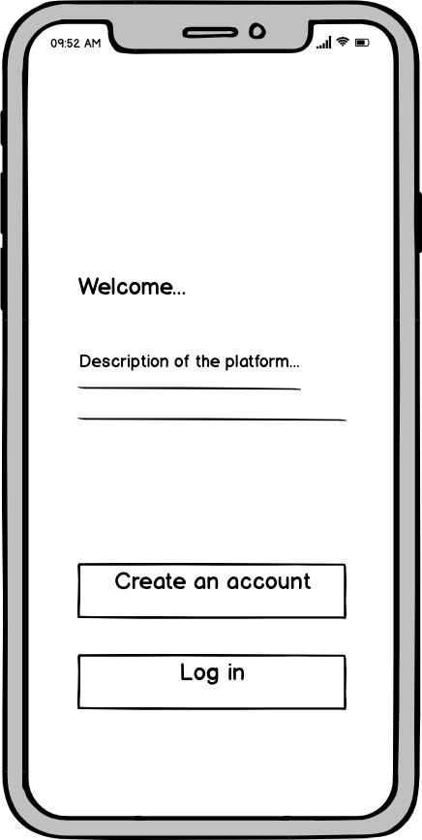⇨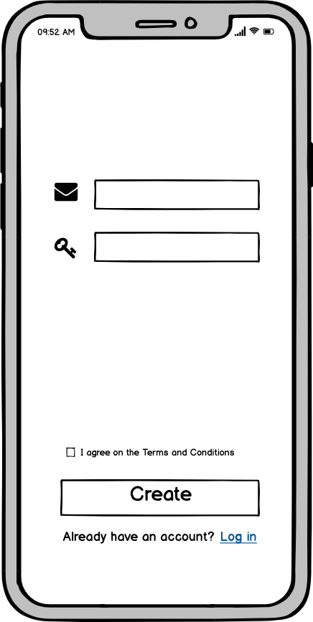⇨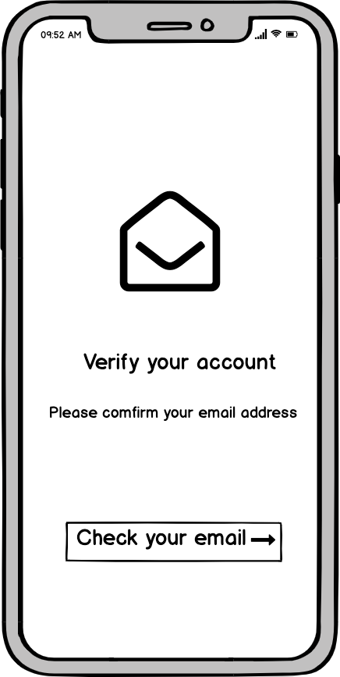

Incorrect Login Attempt Reset Password Successful Verification

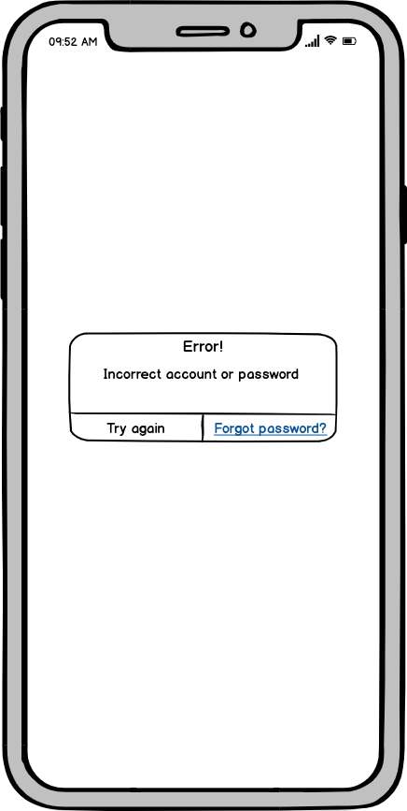⇨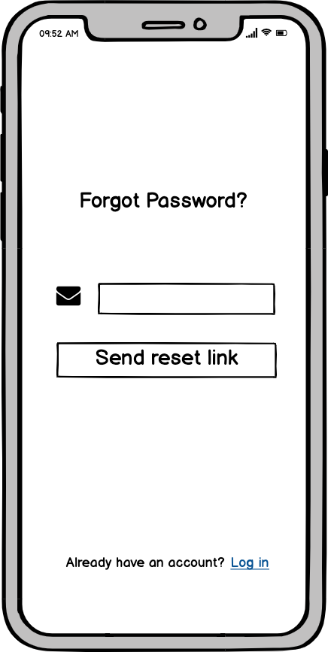⇨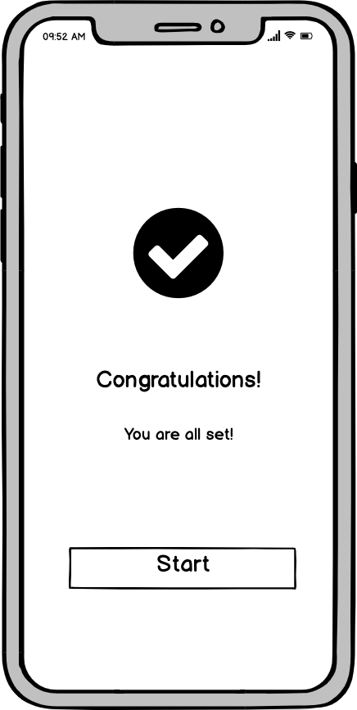

Alternatively, Federated Method Success/Redirect First Login Homepage

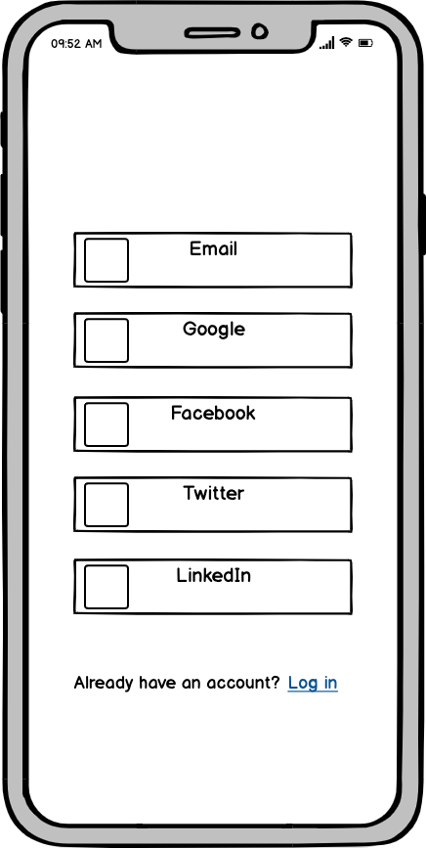⇨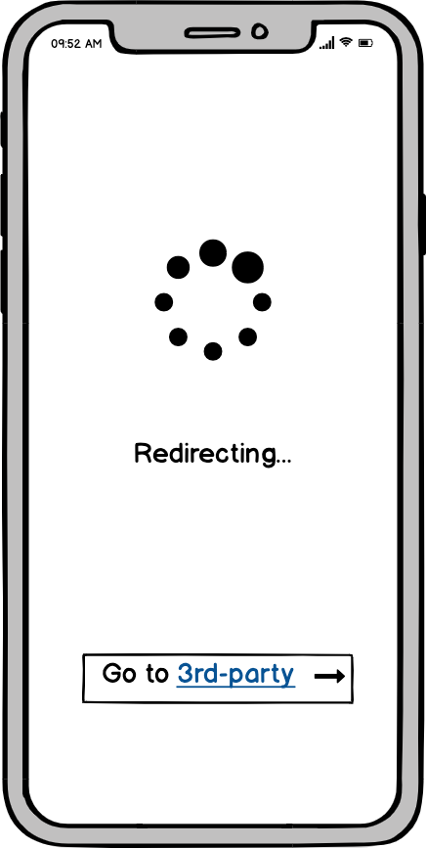⇨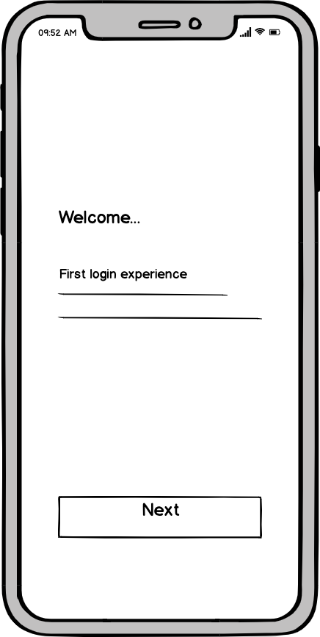

**4.1.2 Create Learning Objective**

Learner Dashboard: No LO Choice of Creating LO Self-Created LO

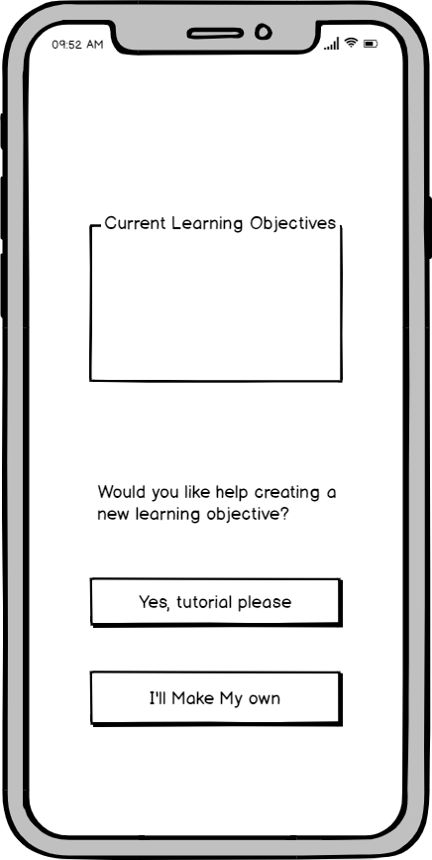⇨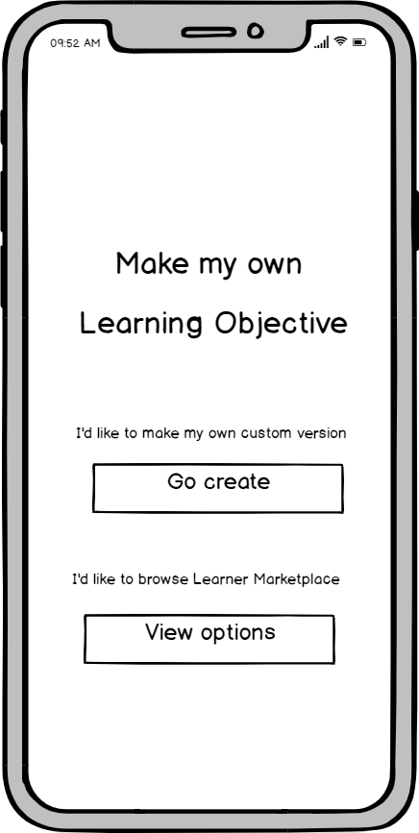⇨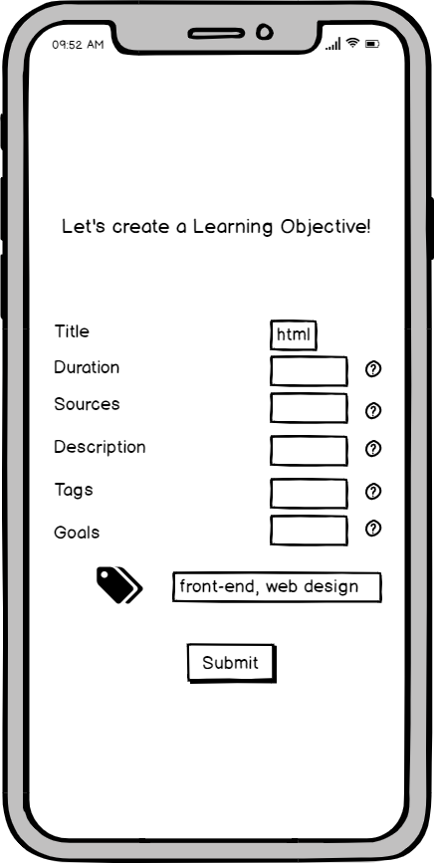

Alternatively, System Guided LO Topic LO Timeline

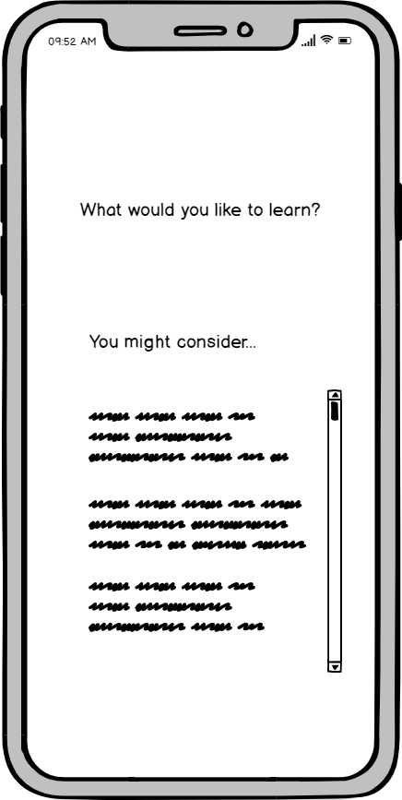⇨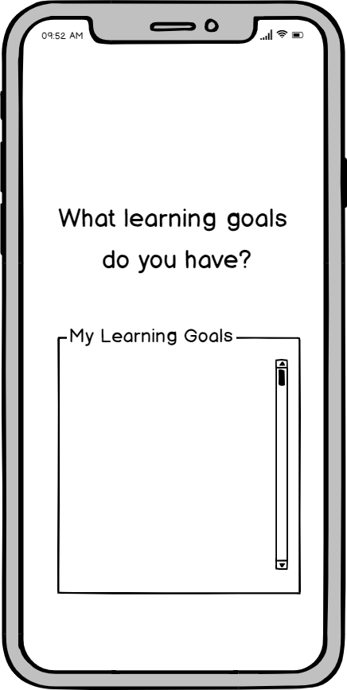⇨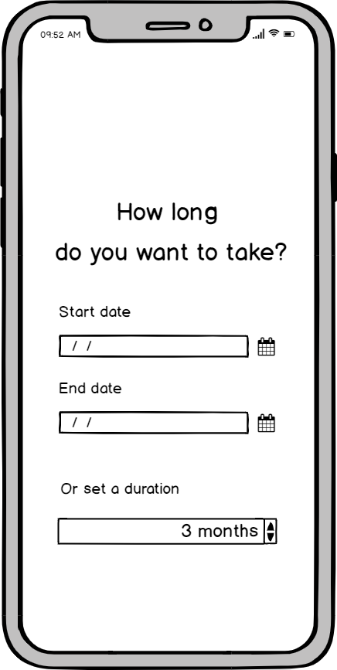

LO Sources LO Description LO Tags

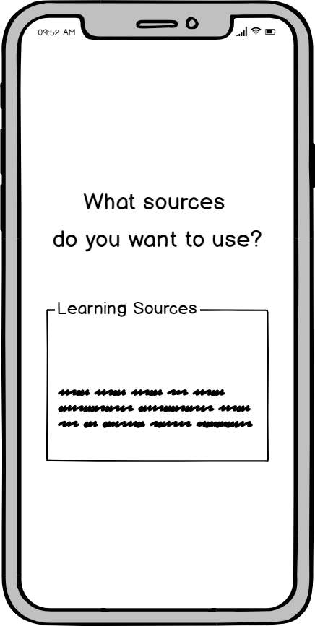⇨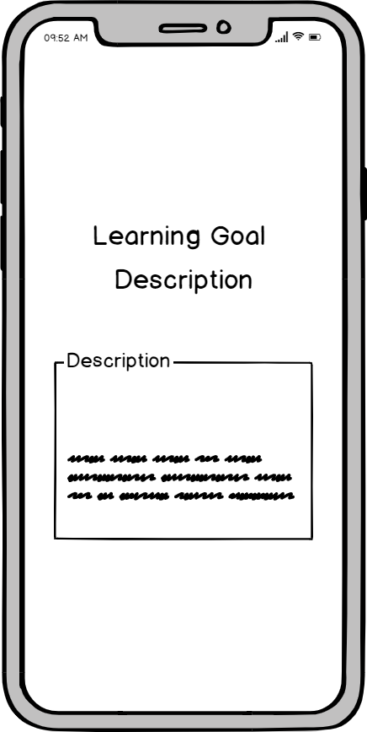⇨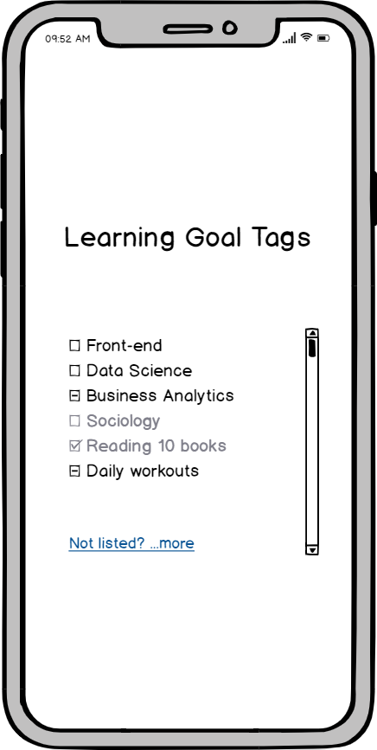

**4.1.3 Create a “curriculum of the week”**

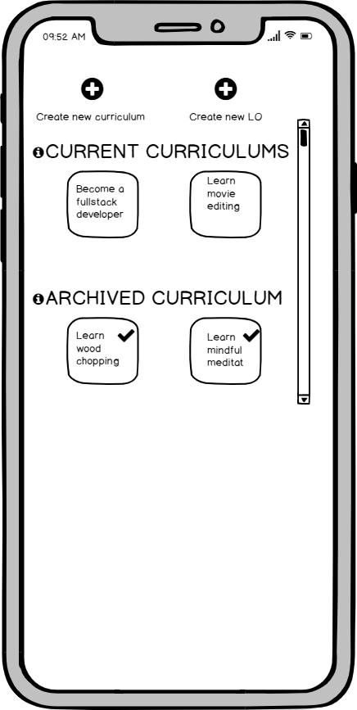 **⇨ 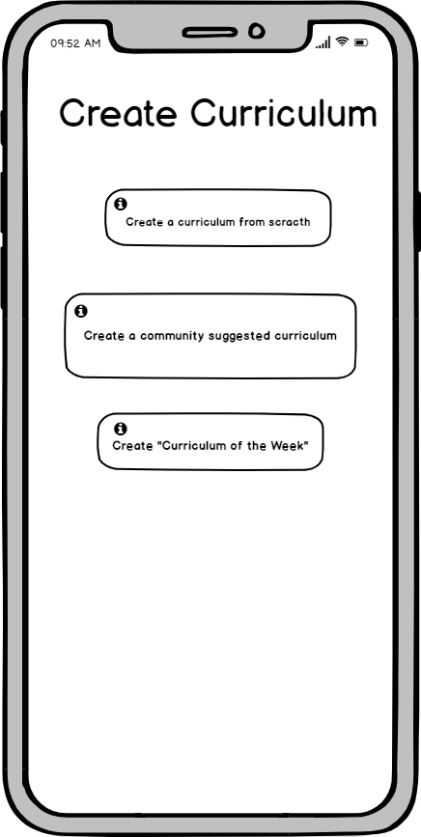 ⇨** 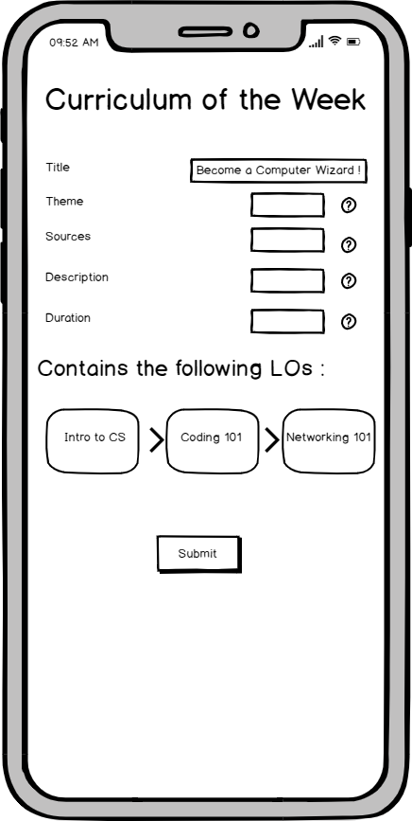

**4.1.4 Publish original curriculums to the community**

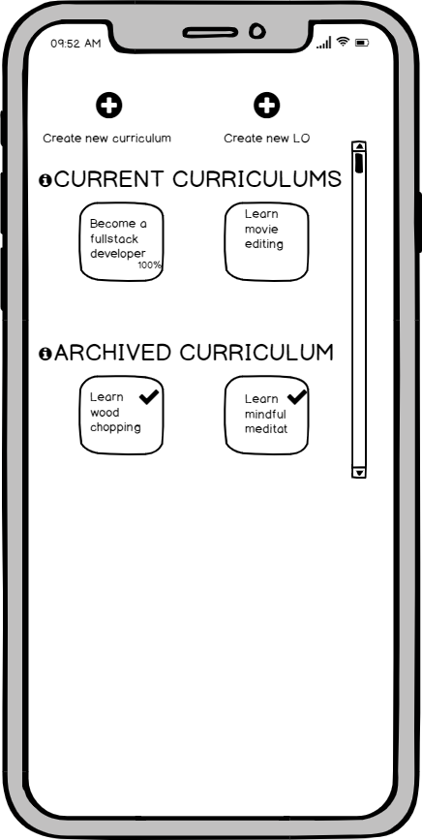   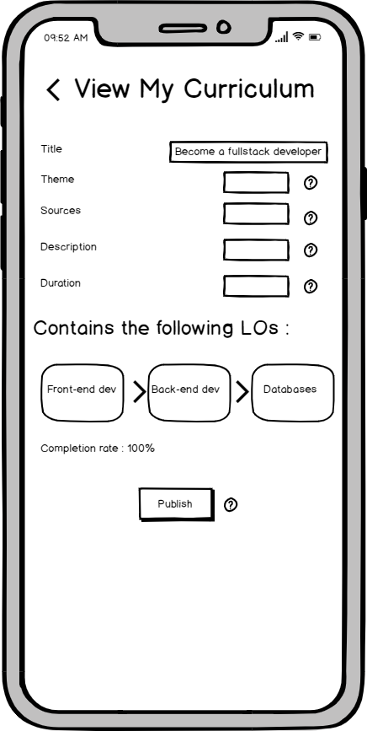

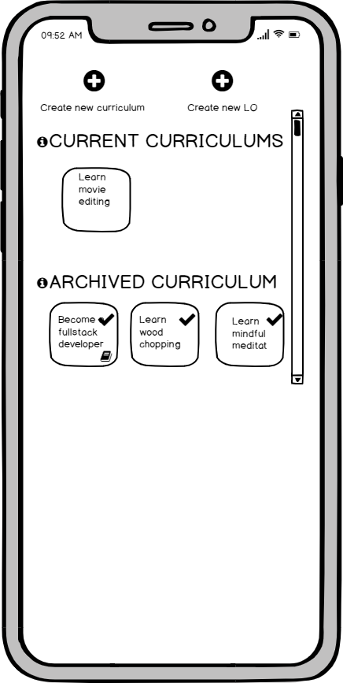  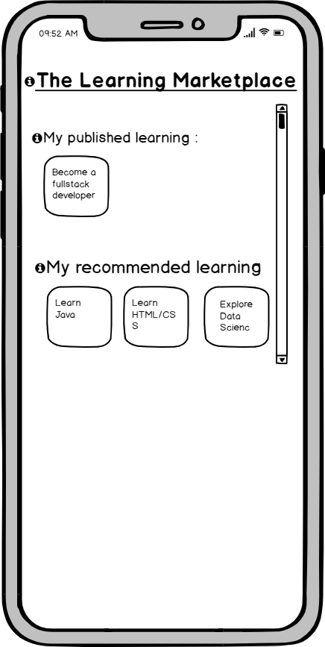

**4.1.5 Create a league**

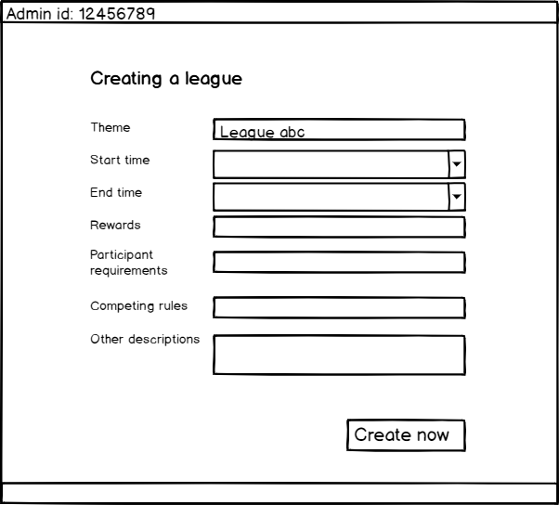 ⇨ 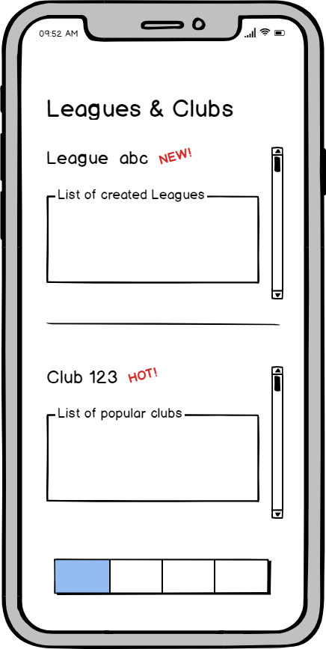

**4.1.6 Create a social network**

To send connect request Request pending A failed attempt

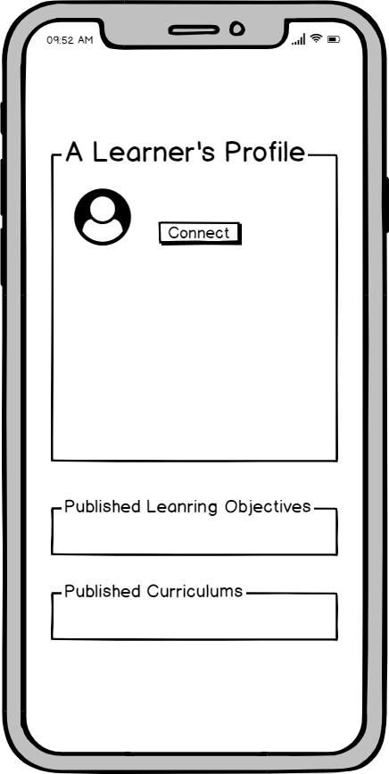⇨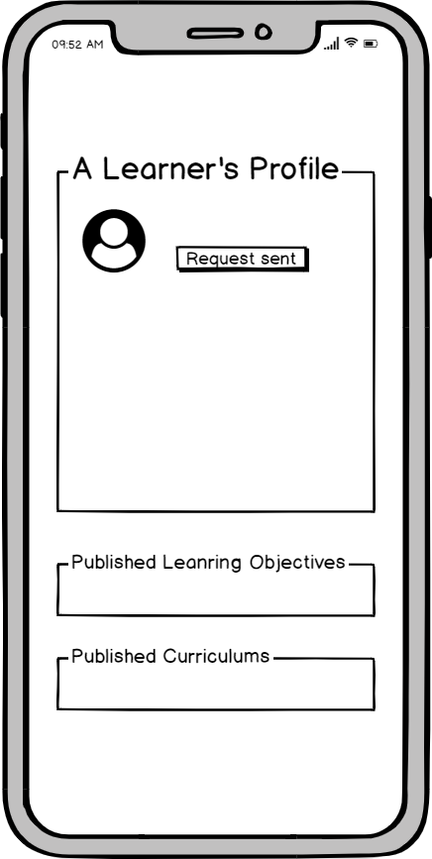⇨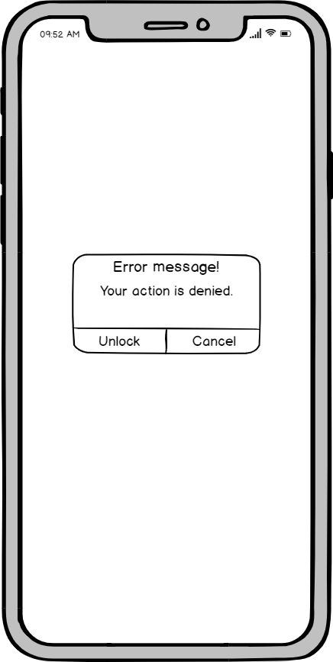

To view the connection list Start a chat with a connected user

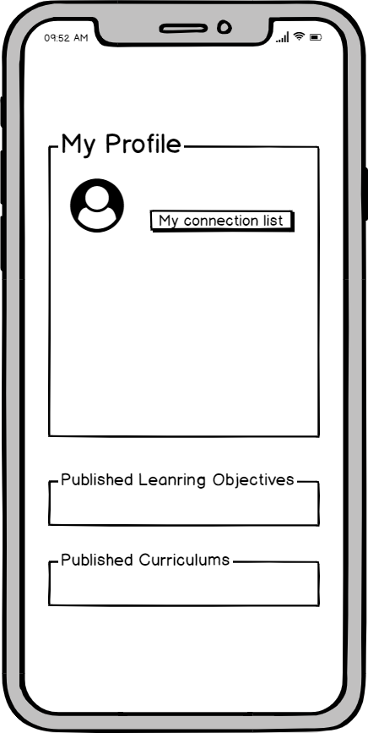⇨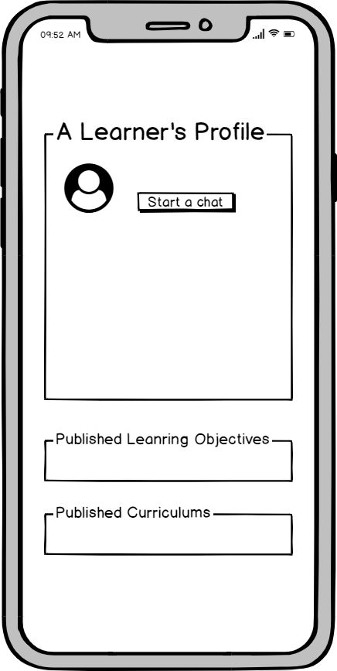

## 4.2 UI/UX Architecture

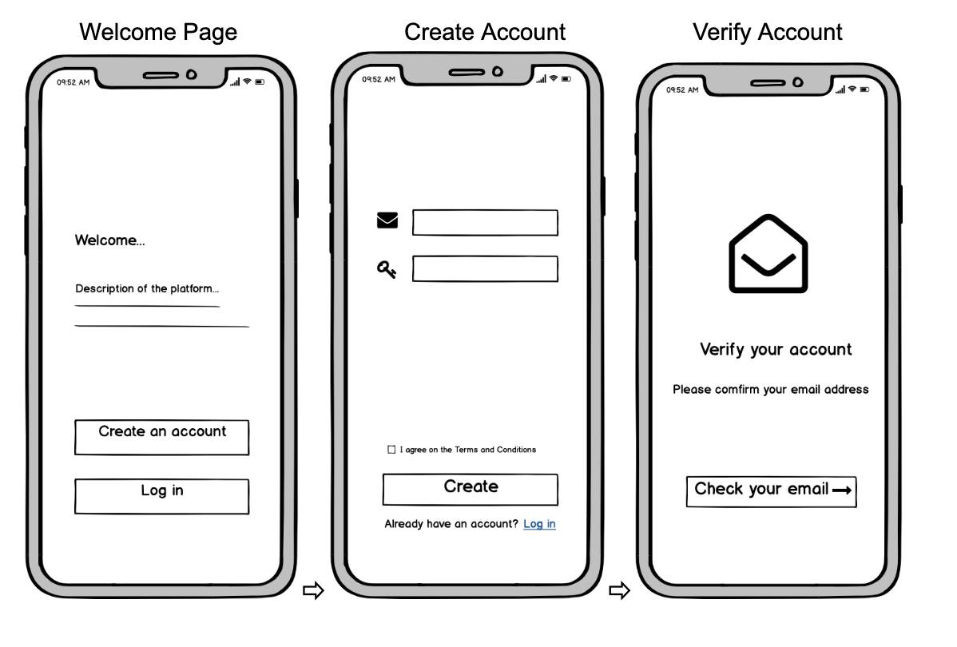⇨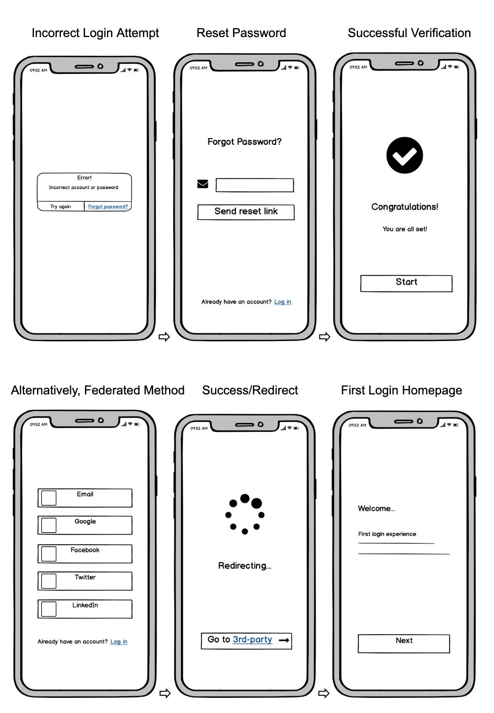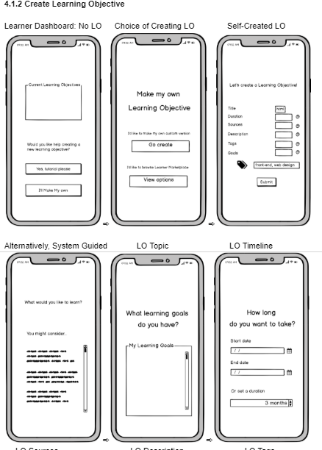 ⇨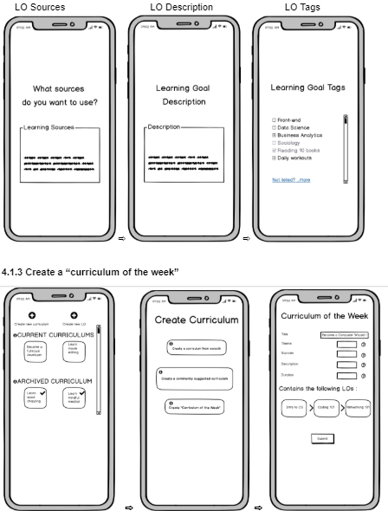⇨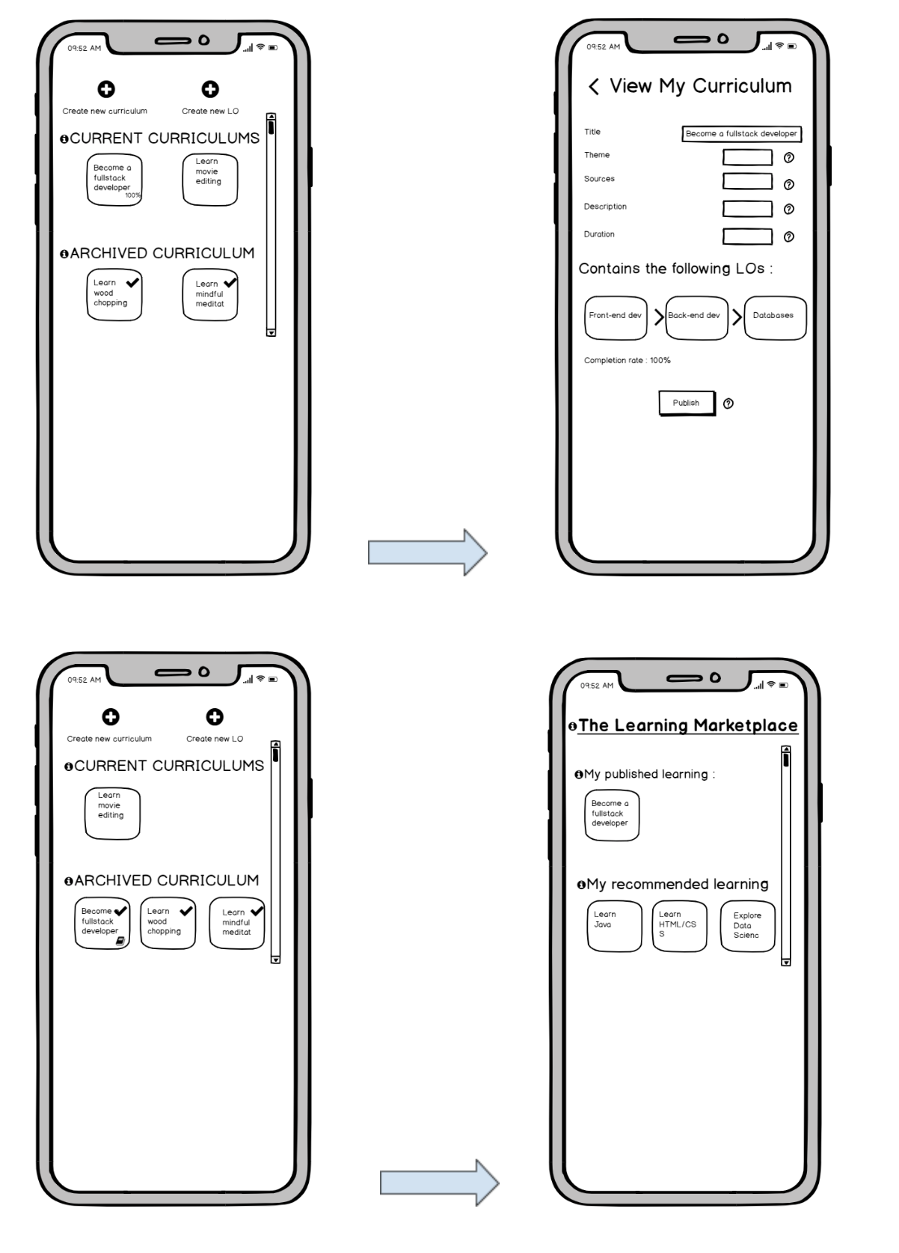

# 5 Data Architecture

## 5.1 Identify Data Entities for each User Story

|  |  |  |
| --- | --- | --- |
| Epic: User Stories | Entities | Description |
| 11:7  12:1,2,3,4,5 | Leagues / Club | Map Learners to League or Club with associated attributes |
| 8:1 | Activity Logs | Capture relevant metrics regarding activity |
| 3:3  4:5  8:3,4  9:3,4,5  10:4,6  15:1,2,3,4,5,6,7,8,9,10,11,12,13,14,15,16,17,18,19,20 | Administrators | Administrator permissions and data metrics, values will be captured in these data entities |
| 2:1  3:4  6:1,2,3,4,5  7:1  8:1,2  9:1,2  10:1,2,3,5,7  11:2,5,6  14:1,2,3,4  16:1,2 | Learners | Data entities focused on the Learner’s progress, objectives, personal information, and so forth. |
| 2:3,5  3:2 | Curriculum | The meta data around curriculum content and that which makes up the content itself |
| 11:1 | Comments | Capture timestamp, relevant tags, person who made comment |
| 10:7 | Chatbot Conversation | Content for bootstrapping AI conversations |
| 11:1,2,3,7 | Learner Chatroom | Meta and content data related to comments |
| 1:1,2,3,4,5,6  2:1,6  3:3,4  7:1  11:4 | Learning Objectives | Discrete content that a Learner might created, included LO’s in progress, archived, and published |
| 11:7  13:1,2,3,4 | Awards | Keep track of awards for each Learner |
| 6:1  14:1,2,3,4 | Config | Variables capturing individualization for dashboard, preferences |
| 2:2,3,4,7,8  3:1,4 | Curriculum | Published content, capturing tags, comments, associated application suggestions |
| 4:1 | 3rd Parties | Handshake between other platforms |

## 5.2 Build data architecture

For the data architecture, we envision approaching a modularized model which will emphasize components and the ability to utilize a variety of technologies in a flexible and dynamic manner. In this section, we describe the main data entities and how they will connect in a logical flow. At this stage, we are technology agnostic. In future stages, as we continue to look more closely into technical implementations, we will be able to select technology-specific formats that might be proprietary, such as the various unique implementations of SQL implementations. Below are some potential data architectural flows that are being considered for system implementation.

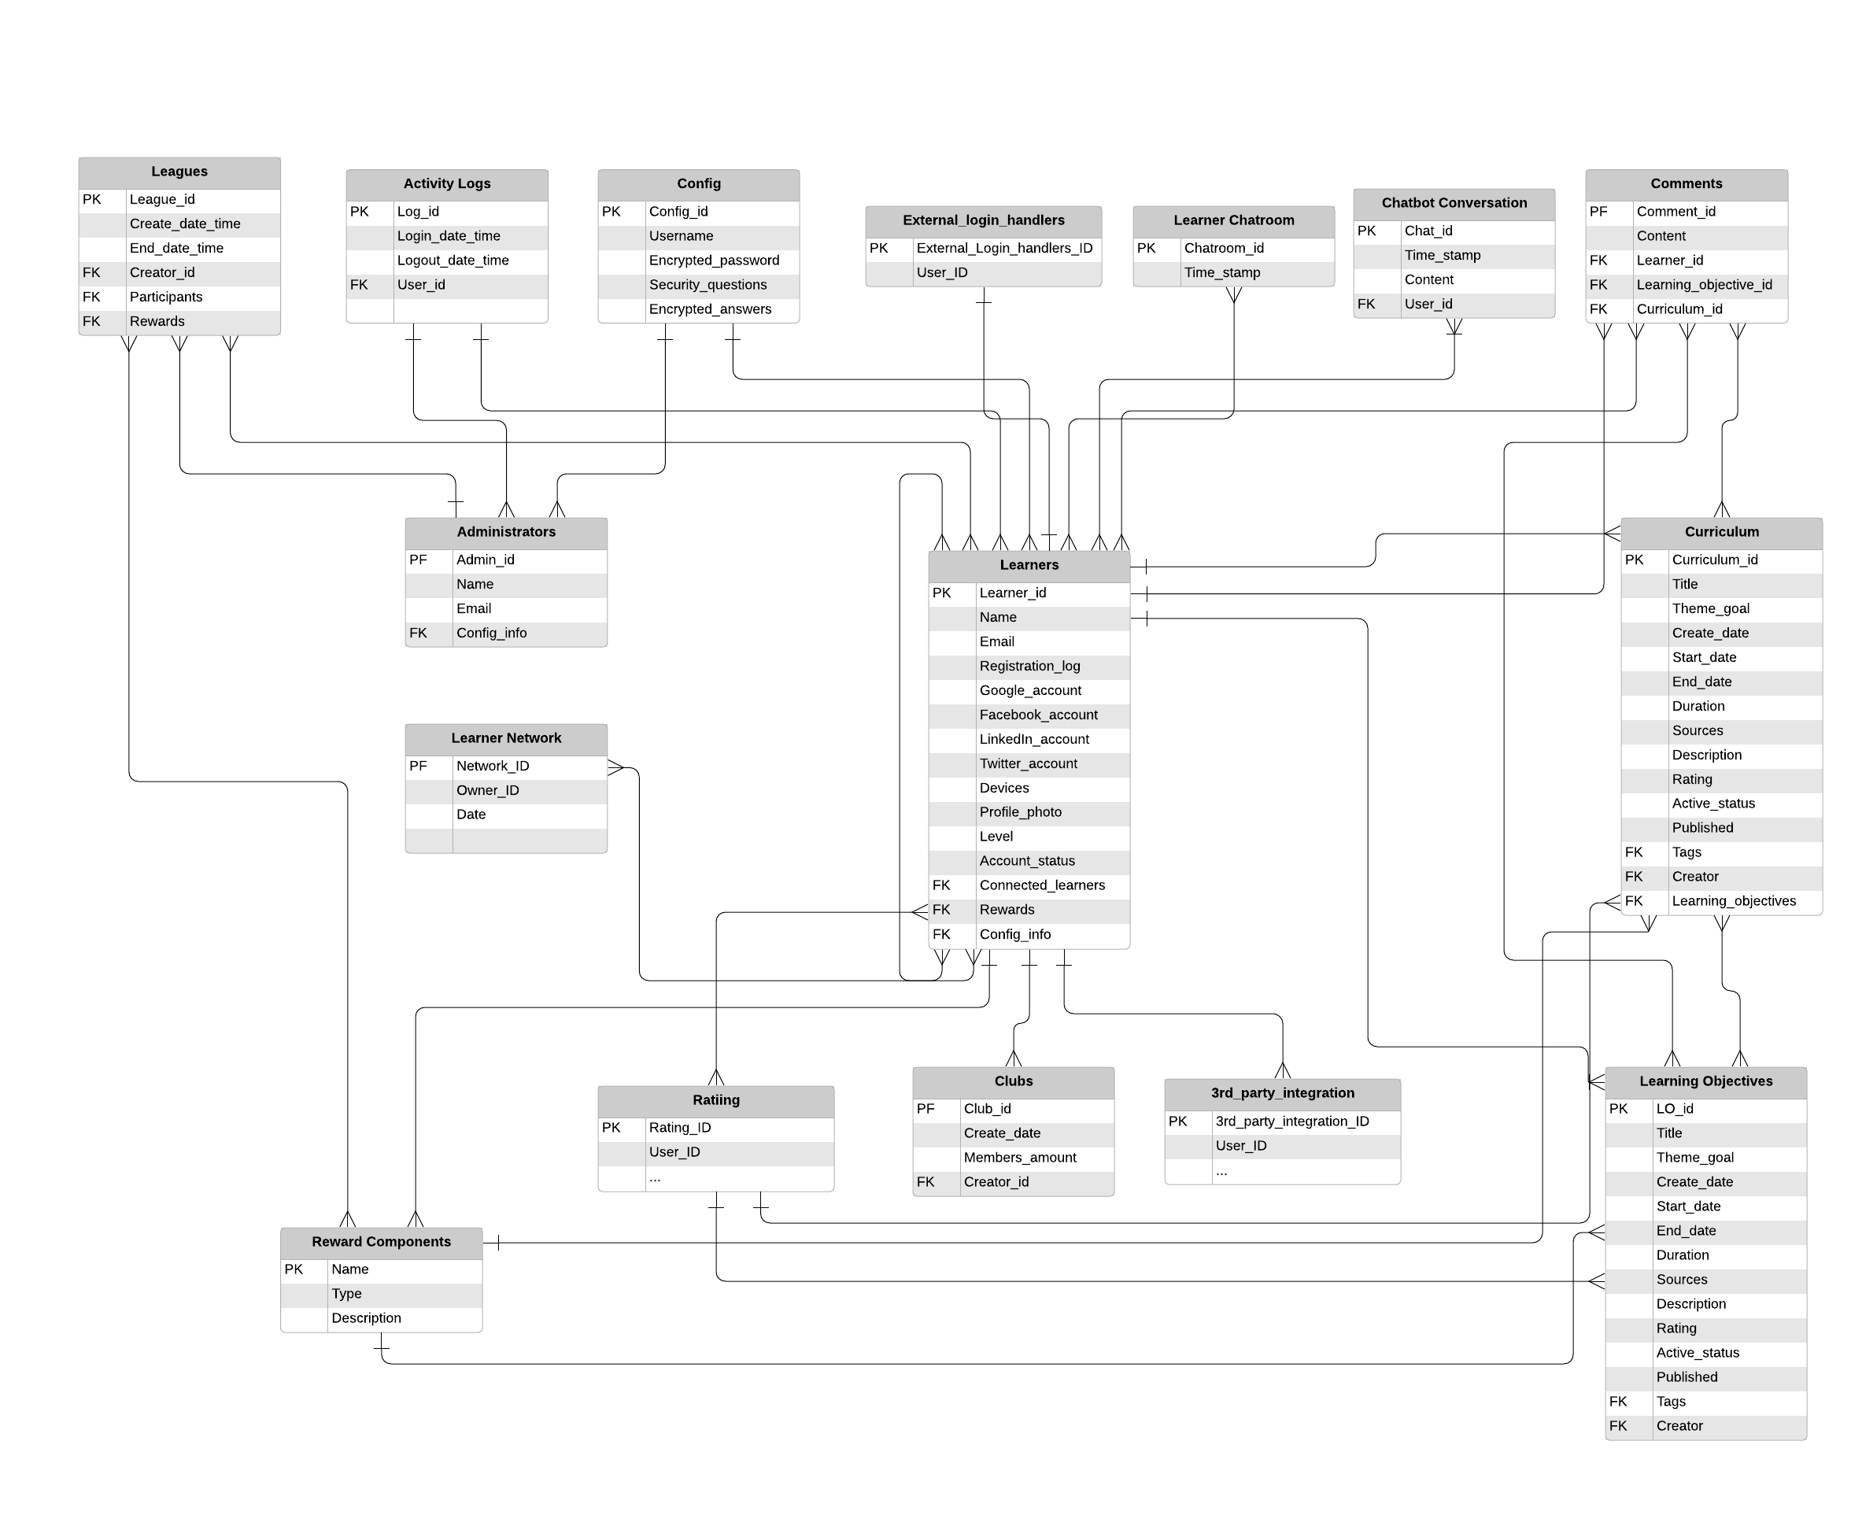

# 6 System level Architectural choices

The application will emphasize usage of cloud deployment, services and infrastructure provided by such major cloud providers as Amazon Web Services (AWS) and Microsoft Azure, which offer robust options around Infrastructure-As-A-Service (IaaS), Platform-As-A-Service (PaaS), and a variety of tools which will directly impact the implementation of this application. By utilizing cloud services, many of the systemic and operating requirements will be met, including minimizing costs, emphasizing scalability and accessibility, interoperability between various hardware and operating systems using the platform, minimization of human involvement with platform setup and maintenance, as well as offering robust security measures through network firewalls, IAM policies, and encryption. In addition, there are a variety of tools, such as federated identity, machine learning models, and more which will increase the richness of the platform.

There are a wide variety of technology options available to the platform administrators, offering increased application performance, security, as well as usefulness in terms of the learner experience. The platform will use a combination of traditional server-client communication utilizing the security-enhanced communications protocol HTTPS. One approach that will be considered in developing the front-end client utilizing a language which offers class-platform support, such as React Native, Apache Cordova, or jQuery Mobile. Utilizing Node.js on the back-end within an EC2 instance, this traditional model can leverage the AWS private network model which allows for controls on internal and external traffic, connection with database instances, as well as the flexibility with connecting with other micros-services that are offered. There are numerous controls that are available to the administrator, ranging from specific IP addresses that can access particular resources such as the database, and indeed such resources can be completely encapsulated by the Virtual Private Cloud (VPC), or the private cloud network. Thus, there are multiple layers of systemic control for ensuring security in terms of application access - from IAM policies, to the setting of new learner password requirements, the level of data encryption both in transit and resting state, and so on. An S3 bucket can be an inexpensive means to store captured data inputted by the learners in a flat file format, while other forms of data might be better served being added to a SQL-friendly database format. The MERN stacks allows for the use of a single language, Javascript, to build a full-stack web application, however other languages, including PHP or Python could be substituted where there are clear advantages.

The choice to use cloud provider infrastructure and services has other implications and benefits. First, the level of administrator work in configuration, patching, and undergoing other maintenance tasks can be minimized through tools that are offered which offers increased automation. This will make it much more easy, and cost-effective, for a minimum amount of staff to be involved in the platform operations on an ongoing basis. Some of the security attributes have been already described, but this increased security is manifested with the immense amounts of infrastructure investments that these large companies are able to invest, with smaller users such as ourselves being able to enjoy such competitive advantage. The ability to auto-scale and auto-replicate resources, either up or down in relation to learner usage, is a powerful option both in minimizing expenses and ensuring minimum latency in terms of learner platform experience. The potential to use edge services to populate data to other regions of the world, as well as the use of machine learning tools that provide chatbot and language translation, will allow this application to have greater performance, usability, agility, as well as serviceability.

The costs associated with using AWS, for example, can be minimized if used strategically. Buy using an AWS free account, good for one year, our platform would be able to have the following resources for no cost:

|  |  |
| --- | --- |
| EC2 Compute instances | 750 hours/ month |
| S3 Secure, duable, scalable object storage | 5 GB / month |
| Managed Relational Database | 750 hours/month |
| DynamoDB NoSQL Database | 25 GB/ month |
| SageMaker Machine Learning managed | 250 hours / month ( 2 months free) |
| Lambda event response | 1 million / month |
| Lightsail virtual private server | 750 hours / month |
| GuardDuty thread detection | 30 days / month |
| SNS push messaging service | 1 million / month |

During this one year, the platform team will be able to focus on scaling up learner user base, increasing automation, and look for any sources of funding needed for operations following. After the one year time period, the application will still have low running costs, as many of the cloud providers offer pay-as-you-go plans. Following are some example pricing:

|  |  |
| --- | --- |
| EC2 | $0.0104 per Hour (t2 micro) |
| S3 Secure, duable, scalable object storage | $0.023 per GB (first 50 TB) |
| Managed Relational Database | $0.017 per hour (t2 micro) |
| DynamoDB NoSQL Database | $0.25 per hou to start |
| SageMaker | $343 /month 1 multi-model endpoint |
| Lamda | $0.000016667 per GB |
| Lightsail | $3.50 / month to start |
| GuardDuty | $1.00/GB first 500GB VPC Flow Log and DNS Log Analysis, then $0.50/GV for next 2000GB  $4.00 / 1M events AWS CloudTrail Event Analysis |
| SNS push notifications | $1.00 / 1 M mobile push notifications |

# 7 Applicable Standards

## 7.1 UI/UX

**Adaptability.** Check how all UI elements are displayed on screens of different sizes and in portrait and landscape orientations.

**Compliance with standards.** Check the app UI for compliance with Google and Apple requirements (human interface guidelines for iPhone/iPad). There are certain elements necessary for normal operation in one OS environment but not needed in the other.

**Human Interface Guidelines** (platform-specific for different mobile versions)

Android Design, IOS Human Interface Guidelines

**U.S. Web Design Standards** which allocate common UI components and visual styles for websites, designed for readability and impact

**Laws of Locality:** put the control where it affects the change

## 7.2 Data regulations / data related

**ISO 27701,** a privacy extension of ISO/IEC 27001 and ISO/IEC 27002, designed to protect and control personal information. It can demonstrate compliance with global privacy regulations around the globe, including GDPR.

**GDPR**: European privacy laws mandate that companies utilizing an individual’s data who is of European nationality must take robust measures to ensure that data is not compromised.

**Canada’s Privacy Act** and **PIPEDA** are concerned with personal information, and how that information is used, stored.

**California Consumer Privacy Act of 2018** (CCPA) requires US companies to implement a number of privacy initiatives similar to that of GDPR.

## 7.3 Accessibility

**Web Content Accessibility Guidelines (WCAG)** is a set of guidelines and standards that meets the needs of various levels of users for accessibility.

**User Agent Accessibility Guidelines (UAAG):** A comprehensive set of checkpoints regarding user access to all content, how content is rendered, control of interface, and standardization of interface.

## 

## 